last updated 27 June 2023

Results Champ Show 2023
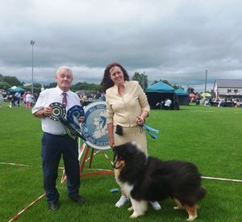
Breed Championship Show held in Kilkenny 24 June 2023
Judge John Catliff

- Green Star Dog and Best in Show: Int Ch, GB Ch, Ir Ch Caronlea Lukin Black JunCh JCW15 CW17 (K McDevitt).
- Green Star Bitch and ResBIS: Monsolina Vorever Blue (P Farrell).
- Res GS Dog: Ch Int Ch Denfris Discovery for Caronlea AnCh22 Cent Ch CW (K McDevitt).
- Res GS Bitch: Ezzmare Westside Pearl (S Nealon).
- Best Pup in Show: Ezzmare Westside Pearl (S Nealon).

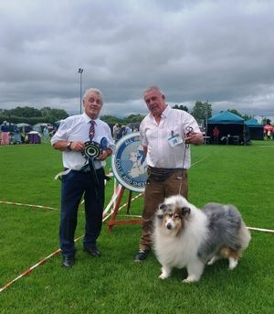
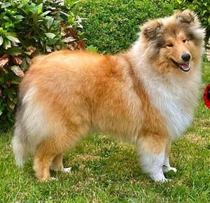

Full Results and Critique
All Ireland Collie & Sheepdog Society - Breed Champ Show 24th June 2023
Judge John Catliff (Mallicott)

~BABY PUPPY DOG
1st J McElligott Donohill Khal Drogo. Lovely length head, nice back skull. Just needs to clear in stop. Lovely placed eye, lovely ears. Lovely length of neck. Good body shape. Good rear quarters. Lovely set tail of good length. Well presented. Movement just needs to lighten up. An exciting puppy.

~MINOR PUPPY DOG.
1st Very Promising. C McTaggart. Bonnettsrath Huggies Smooth Lover. Nice length of head. Stop needs to clear. Nicely shaped eye. Ears a little light, could be caused by the wind. Good length neck. Nice body shape. Correct tail set. Well groomed. A little erratic on the move.

~PUPPY DOG
1st Very Promising. M Delaney Bonnettsrath Leonardo De Vinci. Super tricolour puppy. Lovely length head. Nice back skull. Correct positioned ears. Lovely rounded muzzle. Super eye shape. Excellent underjaw. His white collar shows off his neck. Good shoulder and front. He has lovely boning. His coat is meticulously groomed. He has a lovely body shape and correct tail carriage. Movement first class. An exciting prospect. Best Puppy Dog

~JUNIOR DOG
1st Excellent. J & T Data. Afterhero Vol’jin The Warchief. Lovely neck. Good length head. Well filledforeface. Just needs to clear in stop. Lovely ear placement. Good underjaw. Strong good front. Lovely body shape. Tail correct set carried a little gaily. Movement very good. Presentation good. I would just like a little more trimming on the hocks.
2nd Excellent. A Carter. Little Cub at Retadams. Needs to fill in foreface. Good length head. Ears a little heavy but he can use them. Good neck. Needs a little more body weight. Nice length body and nice topline. Not quite in full coat but well groomed. Movement was adequate.

~ADULT DOG
1st Excellent. D & M Timmins. Beldones Hunky Dory at Kynan. Beautiful head. Lovely moulded foreface. Perfect eye placement. Correctly placed ears. Just enough neck enhanced by collar. Nice shoulder placement. Lovely body shape. Coat of good texture and well groomed. Moved as one with his owner.
2nd Excellent. J & M Ball. Durham Velvet Bear. I really love this tri. Lovely head pattern. Correct eye shape and placement. With his ears up has a lovely expression. His lovely white collar shows off his neck. Lovely body shape – well boned and well presented. Rear movement needs to tighten up.
3rd Excellent. J & T Data. Nibynic A Star Was Born
4th Excellent. A Van Wyk. Otis King

~OPEN DOG
1st Excellent. K McDevitt. Ch Int Ch Denfris Discovery for Caronlea (Imp Russia) AnCh22 Cent Ch CW. Lovely upstanding dog. Excellent size. Good balanced head. Clean stop. Correctly placed almond eyes. Nice ear carriage. Good strong neck. Nice deep chest. Lovely topline. Lovely body shape. Correctly set tail of good length. Loved his bone and his presentation. His movement was excellent. Reserve Green Star
2nd Excellent. M Carr & M Colclough. Donohill Phantom of The Opera. Lovely blue merle. Lovely head. Correctly placed eyes. Clean stop. Nicely placed ears which when lifted gave him a lovely expression. Good neck. Super body shape. Loved his colour. Movement was very good and it was a close decision between 1st and 2nd.
3rd Excellent. S Drewery. Ballahanna Bon Jovi
4th Excellent. D O’Brien. Ezzmare Major Tom

~CHAMPION DOG
1st Excellent. K McDevitt. Int Ch GB Ch Ir Ch Caronlea Lukin Black Jun Ch JCW15 CW17. Gorgeous tri dog. 9½ in tip top condition. Lovely head pattern. Lovely moulded forefae. Super eye placement. When he lifts his ears he has a gorgeous expression. Good strong neck into good shoulders. Super body shape. Excellent boning. Tailset good. Coat presentation excellent. Movement is very good. Green Star Dog and Best in Show
2nd Excellent. S Nealon. Ch Ezzmare King of Hearts. Lovely sable and white. Good head. Nicely placed eye. Clean stop. Good ears which he used non stop. Good neck enhanced by white collar. Nice deep chest. Good length back. Nice topline. Presentation was very good. Moved as one with his handler.
3rd Excellent. S Drewery. Ch Evalane Memory of Monty for Elshadene JunCh

~MINOR PUPPY BITCH
1st Very Promising. S Nealon. Ezzmare Westside Pearl. 8 months. Lovely head for one so young. Clean stop. Beautiful eye placement. Perfect ear placement. When she lifts her ears she has a dreamy expression. Nice neck. Good shoulder. She has lovely boning. Super body shape for one so young. Correct eye set. Coat presentation excellent. Presented a lovely picture on the move. Reserve Green Star. Best Puppy Bitch. Best Pup in Show.

~PUPPY BITCH
1ST Very Promising. A Sweeney. Bonnettsrath Bright Blue Ivy. Lovely blue merle. Still only a baby. Super neck enhanced with her white collar. She has lovely marking through her coat. Correct ear set. She has excellent rear muscle for one so young. Lovely head. Nice stop and eye. Still a little erratic with her ears at the moment. She just needs to lighten up on the move.

~JUNIOR BITCH
1st Excellent. L Hodson. Moyhill Sweet Succession. Lovely sable and white bitch. Nice head pattern. Clean stop. Good foreface. Nicely placed eye. She uses her ears to advantage. An added bonus is her white collar which shows off her neck. Good body shape. She moved with drive.
2nd Excellent. S O’Briain. Nyitramenti Milady De Winter at Seanchrois. Nice size. Foreface just needs to fill in. stop is clean. Nice dark eye. Ears correctly positioned. Nice body shape. Well off for coat which was well groomed. She moved adequately.

~INTERMEDIATE BITCH
1st Excellent. M Delaney. Bonnettsrath Golden Charm. Balanced head – just needs to fill in foreface. Nice clean stop. Eye placement good. Well placed ears. She has a good neck and a deep front. Nicely boned. Nice level topline. Good body shape. Lovely turn of stifle and she has good rear muscle. Tail set is correct. Coat presentation good and she moved with effortless east.

~ADULT BITCH
1st Excellent. S Drewery. Ballahanna Bon Ami. Lovely tri b. super head pattern. Nicely filled foreface. Lovely dark eye shape and placement. When she lifts her ears she has a super expression. Good neck and shoulder. Lovely overall body shape. Nice turn of stifle. Coat shone in the sun. presentation is excellent and she moved very well.
2nd Excellent. A Kelly. Evalane Lockdown Lottie. Pretty sable and white. Lovely head pattern. Nice eye placement. When she lifts her ears she has a lovely expression, she has a good neck and chest. Super body shape and presentation good. Just a little erratic on the move.

~OPEN BITCH
1st Excellent. P Farrell. Monsolina Vorever Blue. Beautiful blue merle. Gorgeous head pattern. Balanced head, clean stop. Lovely eye shape and placement. Ears which she knew how to use. Fabulous neck enhanced by white collar. Nice deep chest. Beautiful boning. Neatly trimmed feed. Body shape is excellent. Tail set good. Colour is well broken and she moved for the substitute handler. Green Star and Reserve BIS
2nd Excellent. M Delaney. Rowlands Love from Maddie. Another lovely blue merle. Balanced head. Nice stop. Rounded muzzle. Good eye shape. Well positioned ears. Nice arched neck. Good deep chest. Excellent body shape. Good topline on the move. Good rear angulation. Handled well for owner. Two very closely matched bitches.
3rd Excellent. A Kelly. Evalane Sweet Fizzie Sherbet JunCh.
4th Excellent. M McNally. Fridens Touch Time with Copamage

~CHAMPION BITCH
1ST Excellent. S Nealon. Ch Ezzmare Cradle With Love. Lovely headed sable and white. Clean stop. Well filled foreface. Good underjaw. Pleasing eye shape. Ears which she could use. Good strong neck. Excellent shoulder placement. Nice length of back. Good body shape. Tailset correct. Nicely groomed. Ample boning and she moved well for her owner.

New Champion in the breed 2023
Congratulations to Sharon Drewery, whose Ch Evalane Sticky Toffee Lollie at Elshadene gained her champion title at IKC St Patrick's National June 2023

Breed Championship Show - 24th June 2023 - judge John Catliff (Mallicot)
Enter online at www.dogshowentry.ie

New Champion in the breed 2023
Congratulations to Sharon Drewery, whose dog Ch Evalane Memory of Monty at Elshadene gained his champion title at Combined Canine National

New International Champion 2023
Congratulations to Karen McDevitt and Billy Henderson whose Ch/Int Ch Denfris Discovery for Caronlea gained his International title at Combined Canine Int.

2022

AICSS Members' Competitions 2022
COMPETITION WINNERS
Circuit Points Competition 2022 >Evalane Memory of Monty Jun Ch & >Ballahanna Bon Ami. Owner Sharon Drewery
Pup/Junior of The Year 2022 >Ch Ezzmare Cradle With Love JunCh, CJW 22. Owner Suzie Nealon
Green Star Dog of The Year 2022 >Ch Denfris Discovery with Caronlea Imp Rus. Owner Karen McDevitt
Green Star Bitch of The Year 2022 >Ch Ezzmare Cradle With Love JunCh, CJW22. Owner Suzie Nealon
Best Newcomer 2022 >Ezzmare Major Tom. Owner Dympna O’Brien
Breeders Cup Winner 2022 >Ezzmare Showdogs, Suzie & Eamon Nealon

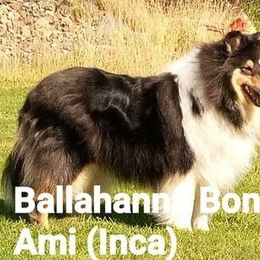
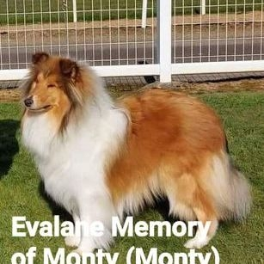
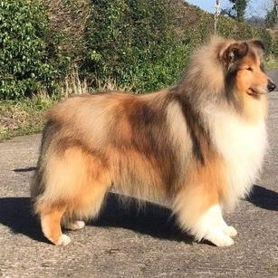
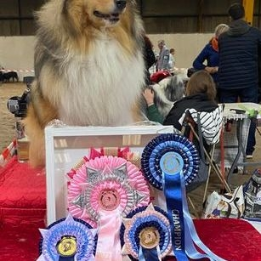
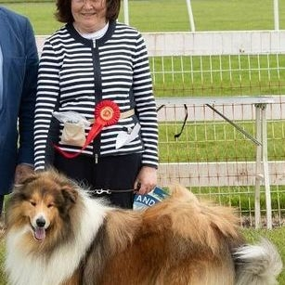
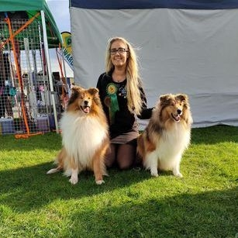
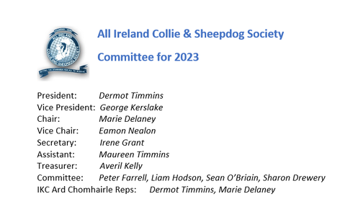

New Champion in the breed 2022
Congratulations to Suzie Nealon whose Ch Ezzmare Cradle with Love gained her Irish title

New Champion in the breed 2022
Congratulations to Karen McDevitt and Billy Henderson whose Ch Denfris Discovery for Caronlea gained his Irish title

New Champion in the breed 2022
Congratulations to Tom Wall whose Ch Daliyhaa Pricilla n Blue gained her Irish title
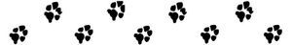
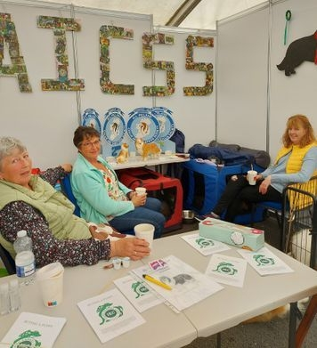
IKC Breed Village May 2022

Our hard working committee had a stand at the IKC breed village - promoting Rough Collies
IRISH KENNEL CLUB Update Statement to IKC Members
MAY 24, 2022
Update Statement to IKC Members
Following the mandate received from the An Ard Chomhairle to examine all options for the National Show Centre, the Board have appointed CBRE to provide a consultancy, advisory, valuation and negotiation service. Once this exercise is complete, all information will be brought back to the An Ard Chomhairle for review, discussion, and a decision regarding what direction the members wish the Board to take.
As you are probably aware CBRE are one of the leading Commercial Estate Agents in the country and have great experience with development lands in the Fingal Area. We have let CBRE know of Fitzwilliam’s interest and have also asked them to contact Fingal Council to seek out their interest. If other parties show an interest, they will be directed to negotiate with CBRE.
In relation to Fitzwilliam, who have made an application to the Planning and Infrastructure Department of Fingal County Council, this is purely to request a review on the Public Safety Zone and Green Belt planning restrictions as part of the upcoming 2023 2028 Strategic Development Plan. It is important to note that the Board of the IKC have not signed any agreement, legally binding or otherwise with Fitzwilliam or indeed any other party.
And just to repeat and emphasise, there will be no decision, or agreements committed to, nor indeed can there legally be, without prior approval of An Ard Chomhairle.
This process is one that is endeavouring to find the best possible advice to assist us in finding a solution for the National Show Centre and the provision of an affordable Show Centre for decades to come.
The work and reports by CBRE will inform us all in a professional manner and will enable us to plan a pathway forward.
BOARD OF DIRECTORS
Irish Kennel Club CLG
24th May 2022

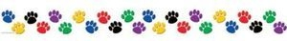
RESULTS AICSS Breed Champ Show 22 May 2022
Judge Peter Farrell (Belrah)

Junior Dog:
1st S Drewery: Evalane Memory of Monty
2nd M Carr/M Colclough: donohill Mr Selfridge
3rd A Van Wyk: Otis King

Adult Dog
1st D O'Brien: Ezzmare Major Tom

Open Dog
1st S Nealon: Ch Ezzmare King of Hearts RESERVE GREEN STAR
2nd M Carr/M Colclough: Donohill King of Narnia
3rd M Carr/M Colclough: Bonnettsrath Poldark At Donohill
4th S Drewery: Ballahanna Bon Jovi

Champion Dog
1st K McDevitt: Ch Caronlea Lukin Black GREEN STAR AND BEST IN SHOW
2nd S Nealon: Ch Ezzmare Huggy Bear

Baby Puppy
1st M Delaney: Bonnettsrath Golden Charm BEST BABY PUPPY
2nd M Delaney: Bonnettsrath Queen of Hearts

Puppy Bitch
1st S Nealon: Ezzmare Cradle with Love BEST PUPPY IN SHOW & RESERVE GREEN STAR
2nd A Van Wyk: Princess Lola

Junior Bitch
1st A Kelly: Evalane Loveable Lockdown Lottie
2nd S Croly: Princess Linnau
3rd M Delaney/S Nealon: Rowlands Love from Maddie

Intermediate Bitch
1st R Bollard: Bonnettsrath Sunfower
2nd S Drewery: Ballahanna Bon Ami
3rd S O'Briain: Seanchrois Jewels Joy

Open Bitch
1st D&M Timmins: Donohill Could This be Magic for Kynan CW22. GREEN STAR BITCH & RESERVE BEST IN SHOW
2nd S Drewery: Evalane Sticky Toffee Lollie At Elshadene
3rd A Kelly: Evalane Sweet Fizzie Sherbet

Veteran Bitch
1st A Kelly: Rowlands Abbie The Beautiful Lass at Evalane

AICSS Breed Champ Show Photos May 2022
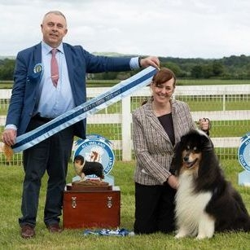
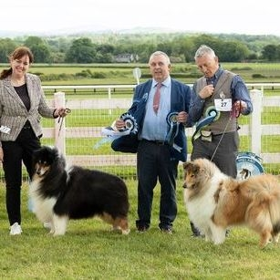
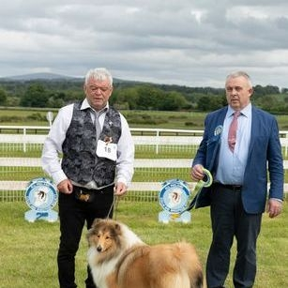
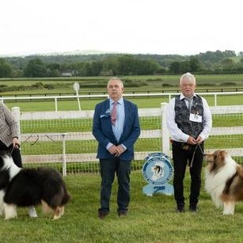
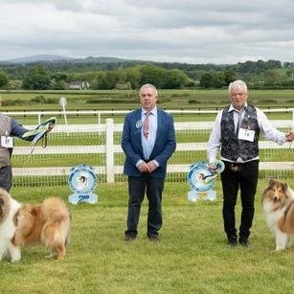

Breed Show

Rough Collie Breed Championship Show (ikc licence applied for)
Sunday 22nd May 2022 (in conjunction with Navan)
Venue: Naas Racecourse
Judge: Peter Farrell (Belrah)

schedules and all details are on onlinedogshows.eu

click here for details and online entry
https://www.onlinedogshows.eu/en/Show/Index/2406/AllIrelandCollie_SheepdogSociety

any questions can be emailed to Irene colliesociety@yahoo.com

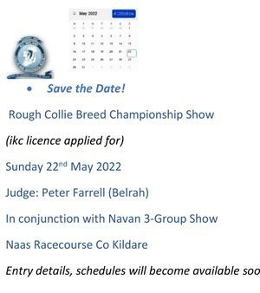

2021

AGM 2021
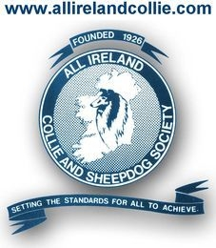
Because of the Covid 19 pandemic, no AGM was held in 2020 or 2021

Committee for 2022

President: Dermot Timmins
Vice President: Liam Hodson
Chair: Sean O’Briain
Vice Chair: Marie Delaney
Hon Secretary: Irene Grant
Assistant Secretary: Maureen Timmins
Hon Treasurer: Averil Kelly
Committee Members: George Kerslake, Eamon Nealon, Peter Farrell, Sharon Drewery, Lynn Kilby
IKC Ard Chomhairle Reps: Dermot Timmins and Irene Grant

Pups for Sale
NOTE. Prices vary amongst breeders. The average price for Rough Collie puppies from reputable breeders is currently €800 to €1400. The AICSS believes that excellent quality pups are available from our members within this average price range - however, it is ultimately between buyer and seller. The club cannot be held responsible for any issues between the buyer and seller.
The AICSS is simply advising of the AVERAGE price for information purposes only – and takes no responsibility.

GDPR. Potential buyers who contact the AICSS may have their email address shared with AICSS member breeders, but we never share information with third parties.

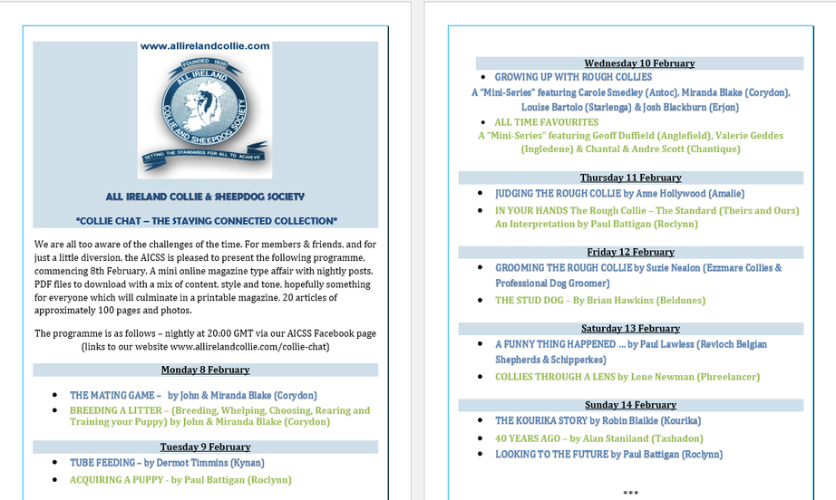

2020

Due to the pandemic, no Irish dog shows took place in 2020.
If our club shows take place in 2021 we will announce it on our facebook page, and here on the website, and will email the members.

Stay safe

Committee for 2021:
President: Dermot Timmins
Vice President: Liam Hodson
Chair: Sean O’Briain
Vice Chair: Marie Delaney
Hon Secretary: Irene Grant
Assistant Secretary: Maureen Timmins
Hon Treasurer: Averil Kelly
Committee Members: George Kerslake, Eamon Nealon, Peter Farrell, Sharon Drewery, Noel Smith, Lynn Kilby
IKC Ard Chomhairle Reps: Dermot Timmins and Irene Grant

AGM September 2019
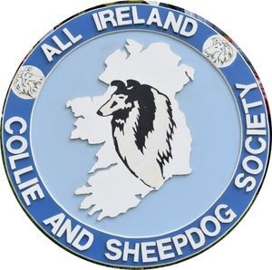
Committee for 2020

President: Dermot Timmins
Vice President: Liam Hodson
Chair: Sean O’Briain
Vice Chair: Marie Delaney
Hon Secretary: Irene Grant
Assistant Secretary: Maureen Timmins
Hon Treasurer: Averil Kelly
Committee Members: George Kerslake, Eamon Nealon, Peter Farrell, Sharon Drewery, Noel Smith, Lynn Kilby
IKC Ard Chomhairle Reps: Dermot Timmins and Irene Grant

Our May and July club shows have been postponed due to the COVD-19 pandemic
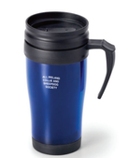
FREE GIFT FOR CLUB MEMBERS

FREE travel mug for every club member who attends our Champ Show in July

FREE one year membership for new-to-the-breed owners who buy a pup from one of our members

New Champion in the Breed 2019
Congratulations to Mary McNally, whose Ch Copamage I'm Blown Away gained her title at Navan, August 2019

2019 Champ Show Critique

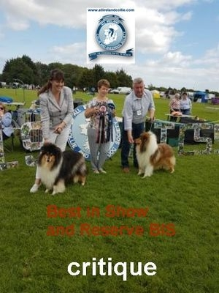

Click to read Judge Sam Wrisdale's CRITIQUE

Parade of Irish Champions 2019
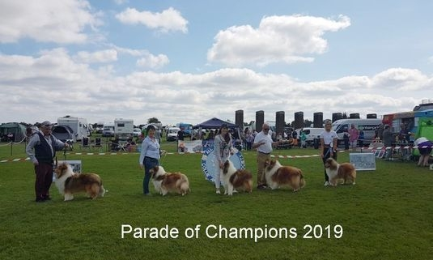
Parade of Champions 2019

Left to Right.......
Eamon Nealon with Ch Ezzmare Huggy Bear,
Averil Kelly with Ch Rowlands Abbie The Beautiful Lass at Evalane,
Karen McDevitt with Ch Caronlea Charlie Brown AnCh18,
Tom Conway with Ch Chantique Errol Flynn at Alwaycon,
Suzie Nealon with Ch Ezzmare King of Hearts JunCh

Competition Results 2019
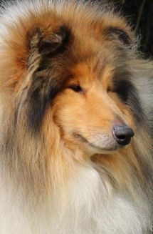
Green Star Dog of The Year 2019:-

Ch Caronlea Charlie Brown AnCh18 - Karen McDevitt

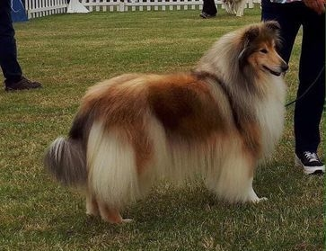
Green Star Bitch of The Year 2019:-

Ch CIB Copamage Lily Langtree JunCh VetCh - Mary McNally

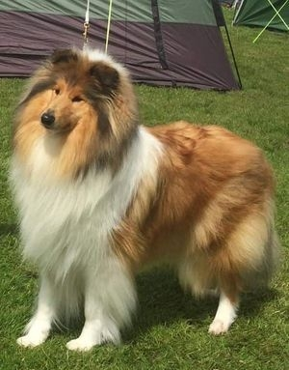
Puppy/Junior of The Year 2019:-

Evalane Sticky Toffee Lollie at Elshadene JunCh - Sharon Drewery

Championship Show July 2019 Results
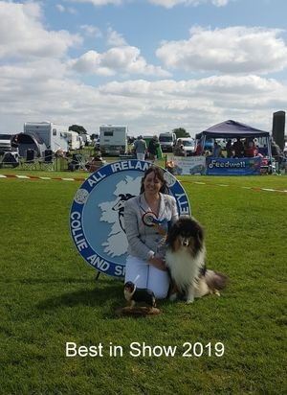
AICSS Breed Champ Show - July 2019 - Judge: Sam Wrisdale (Sachenda)
Class 1 Baby Puppy Dog (No Entries)
Class 2 Minor Puppy Dog (No Entries)
Class 3 Puppy Dog (2 Entries, 1 Absent)
1st Carr & Colclough M&M Donohill King Of Narnia. (Reserve Green Star And Best Puppy Dog And Best Pup In Show)
Class 4 Junior Dog (2 Entries, 2 Absent)
Class 5 Intermediate Dog (2 Entries, 1 Absent)
1st Hodson, L Moyhill Red Rock.
Class 6 Adult Dog (4 Entries, 1 Absent)
1st Nealon, S Ezzmare King Of Hearts.
2nd Farrell, P Belrah Jazzsinger.
3rd Drewery, S Ballahanna Bon Jovi.
Class 7 Open Dog (5 Entries, 3 Absent)
1st Mcdevitt, K Ch Caronlea Charlie Brown Anch18. (Green Star Dog And Reserve Best In Show)
2nd Kelly, L Ballahanna All Guns Blazin.
Class 8 Champion Dog (5 Entries, 4 Absent)
1st Nealon, S Ch Ezzmare Huggy Bear.
Class 9 Pre Veteran Dog (No Entries)
Class 10 Veteran Dog (2 Entries, 1 Absent)
1st Ball, M&J Rosschell Kiss’n The Dark At Durham.
Class 11 Childrens Handling 8-11 (No Entries)
Class 12 Childrens Handling 12-14 (No Entries)
Class 13 Junior Handling 15-17 (No Entries)
Class 14 Baby Puppy Bitch (No Entries)
Class 15 Minor Puppy Bitch (No Entries)
Class 16 Puppy Bitch (2 entries)
1st Kelly, L Samhaven Sister Sara With Ballahanna. (Best Puppy Bitch)
2nd Hodson, L Sweet Eleanor Moyhill. Sable & White.
Class 17 Junior Bitch (1 Entry, 1 Absent)
Class 18 Intermediate Bitch (5 Entries, 2 Absent)
1st Drewery, S Evalane Sticky Toffee Lollie At Elshadene Junch.
2nd Mcnally, M Copamage I’m Blown Away Junch.
2nd Kelly, A Evalane Sweet Fizzie Sherbet Junch.
Class 19 Adult Bitch (No Entries)
Class 20 Open Bitch (10 Entries, 6 Absent)
1st Ball, M&J Clondegad Phi Cassiopeiae. (Reserve Green Star Bitch)
2nd Farrell, P Monsolina Vorever Blue.
3rd Mcdevitt, K Denfris Eternal Flame For Caronlea (Imp Rus).
4th Conway, T Meryctin Sparkle Forever At Alwaycon..
Class 21 Champion Bitch (5 Entries, 4 Absent)
1st McDevitt, K Multi Ch, Int Ch, Grand Ch Caronlea Hot Celtic Charm Junch. (Green Star Bitch And Best In Show)
Class 22 Pre Veteran Bitch (2 Entries, 1 Absent)
1st Kelly, A Ch Rowlands Abbie The Beautiful Lass At Evalane.
Class 23 Veteran Bitch (4 Entries, 4 Absent)
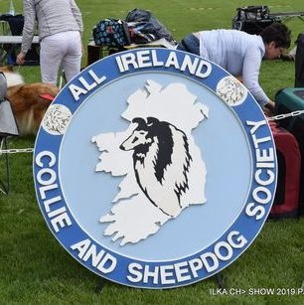
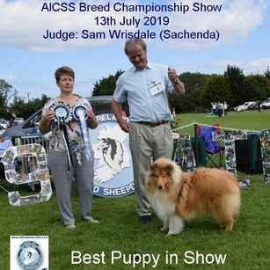
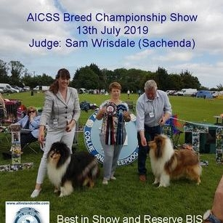
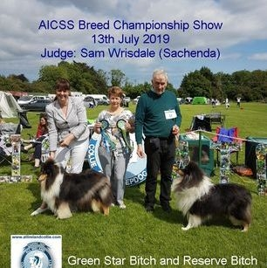
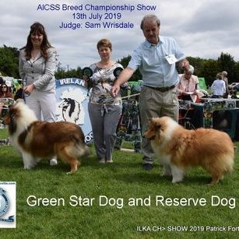

New Champion in the breed 2019
Congratulations to Suzie and Eamon Nealon with their new champion Ch Ezzmare King of Hearts JunCh - who gained his title at Bray, July 2019

New Champion in the breed 2019
Congratulations to Marie Delaney with her new champion Ch Rowlands Gorgeous Gael, who gained his title at Deise, June 2019

New Champion in the breed 2019
Congratulations to Tom Wall with his new champion Ch Daliyhaa Chique, who gained her title at Native Breeds of Scotland, June 2019

New Champion in the breed 2019
Congratulations to Suzie and Eamon Nealon with their new champion Ch Ezzmare Huggy Bear - who gained his title at Cork & District, June 2019

New Champion in the breed 2019
Congratulations to Tom Wall and A Walsh with their new champion Ch Hawkfield's Return to Sender to Joshren at Daliyhaa who gained his title at Munster Canine, June 2019

AICSS Breed Open Show 11 May 2019 - Judge Mervyn Webb (Cassellwebb)
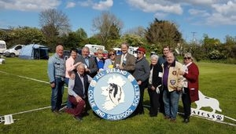
RESULTS AND CRITIQUE..................

AICSS Breed Open Show - May 2019
Judge: Mervyn Webb (Cassellwebb)
- Best Dog & Reserve BIS: ESZMARE HUGGY BEAR (Suzie Nealon)
- Reserve Dog: EZZMARE KING OF HEARTS (Suzie Nealon)
- Best Bitch & Best in Show: MONSOLINA VOREVER BLUE (Peter Farrell)
- Reserve Bitch: BONNETTSRATH SALLY (Marie Delaney)
- Best Pup in Show: DENFRIS DISCOVERY FOR CARONLEA (Karen McDevitt)
Class 1 Baby Puppy Dog (no entries)
Class 2 Minor Puppy Dog (2 entries, 1 absent)
1st McDevitt, K DENFRIS DISCOVERY FOR CARONLEA. S/W dog – nice head, flat skull, good ears. Good reach of neck. Good line of stifle and good coat. BEST PUPPY IN SHOW
Class 3 Puppy Dog (2 entries, 1 absent)
1st Kelly, L BALAHANNA ALL BETS OFF. Nice S/W in good condition. Good head, nice eye and nice neat ears. Nice length of body with well set tail. Little loose on the move and slightly close behind – am sure will improve with age.
Class 4 Junior Dog (No entries)
Class 5 Intermediate Dog (2 entries, 2 absent)
Class 6 Adult Dog (3 entries)
1st Nealon, S EZZMARE KING OF HEARTS. Lovely S/W in very good condition. Nice head and eye. Nice ears and good conformation. Moved well front and back. Nice turn of stifle and short hocks. Pleasure to judge
2nd O’Briain, S SEANCHROIS I’M THE ONE. Nice shaded sable dog. Beautiful head, eye and ears. Good reach of neck. Coat in good condition. Not at is best today and would like to have seen him a little more settled but a worthy second.
3rd Drewery, S BALLAHANNA BON JOVI. A nice golden sable dog. Would have liked a little more underjaw and a slight little more stop. Good ears which he used well. Good confirmation. A little short of coat on the day.
Class 7 Open Dog (3 entries, 2 absent)
1st Nealon, S ESZMARE HUGGY BEAR. Lovely shaded sable dog with good head and eye. Neat ears which he used quite well. Good reach of neck. Nice length of body and very good overall conformation with a lovely turn of stifle. All in all a masculine dog. Moved really well. BEST DOG and RESERVE BEST IN SHOW
Class 8 Champion Dog (1 entry, 1 absent)
Class 9 Pre Veteran Dog (no entries)
Class 10 Veteran Dog (no entries)
Class 11 Childrens Handling 8-11 (no entries)
Class 12 Childrens Handling 12-14 (no entries)
Class 13 Junior Handling 15-17 (no entries)
Class 14 Baby Puppy Bitch (1 entry)
1st Kelly, L SAMHAVEN SISTER SARA WITH BALLAHANNA. Beautiful golden sable puppy bitch – 4 months old. Lovely head, eye and ears. Good underjaw. Good reach of neck. Nice overall conformation. A puppy with a very promising future. Superb temperament.
Class 15 Minor Puppy Bitch (no entries)
Class 16 Puppy Bitch (1 entry)
1st Delaney, M DONOHILL ROCKING ROBIN. S/W bitch. Good head, nice flat skull. Ears a little heavy at the moment. Good reach of neck. Good coat for age. Moved reasonably well. BEST PUPPY BITCH
Class 17 Junior Bitch (1 entry)
1st Delaney, M BONNETTSRATH SALLY. Lovely sable and white bitch. Good head and eye. Nice flat skull. Good underjaw. Ears a little heavy. Lovely conformation and good reach of neck. Lovely turn of stifle. Moved and handled really well.
Class 18 Intermediate Bitch (3 entries)
1st Drewery, S EVALANE STICKY TOFFEE LOLLIE. Nice golden sable bitch in lovely condition. Good head and eye. Nice flat skull and good underjaw. Ears a little heavy. Lovely conformation and a good reach of neck. Lovely turn of stifle, moved and handled really well.
2nd Kelly, A EVALANE SWEET FIZZIE SHERBET. Nice golden sable bitch with a nice head pattern. Lovely eye. Ears slightly heavy. Good conformation and in good condition. Moved and handled well.
3rd Timmins, D&M DONOHILL COULD THIS BE MAGIC FOR KYNAN. Sable bitch. Nice head and eye. Ears a little heavy. She was a little heavy which affected her front movement. Professionally handled on the day.
Class 19 Adult Bitch (1 entry, 1 absent)
Class 20 Open Bitch (6 entries, 1 absent)
1st Farrell, P MONSOLINA VOREVER BLUE. Beautiful blue merle bitch of 3 years. Lovely head, eye and ears. Good stop. Nice underjaw. Beautiful reach of neck accentuated by a huge white collar. Beautiful blue colour well broken up. Lovely overall conformation. Lovely turn of stifle and lovely short hocks. Moved well. BEST BITCH AND BEST IN SHOW
2nd Conway, T MERYCTIN SPARKLE FOREVER AT ALWAYCON. 22 months lovely chiselled head. Good underjaw, very nice clean stop. Nice neat ears. Good compact conformation. Good bone. Nice reach of neck. Not in full coat yet. A very promising bitch.
3rd Delaney, M BONNETTSRATH MONA LISA. 4 year old slightly shaded sable bitch. Good overall head pattern. I would like a sweeter eye. Good reach of neck and good overall conformation. Very good coat and condition. A little loose on the move.
4th Timmins, D&M EVALANE SUGAR COTTON CANDY FOR KYNAN.
5th Nealon, S RIVERSIDE SONG C’EST LA VIE
Class 21 Pre Veteran Bitch (no entries)
Class 22 Veteran Bitch (1 entry, 1 absent)
11th May 2019
Mervyn Webb (Cassellwebb)
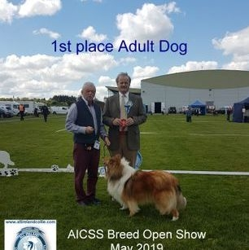
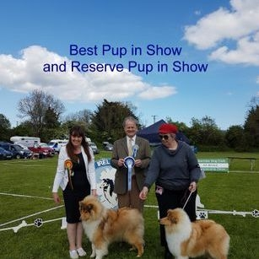
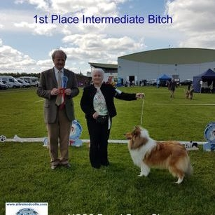
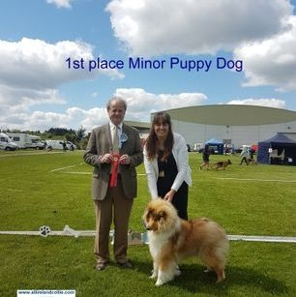
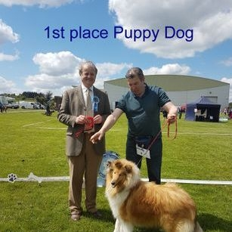
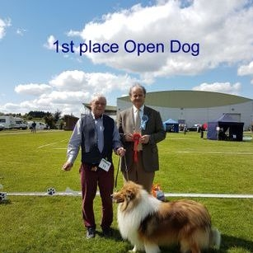
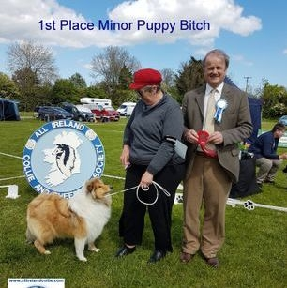
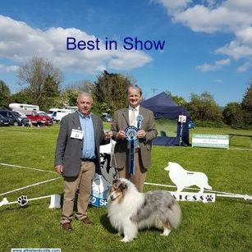
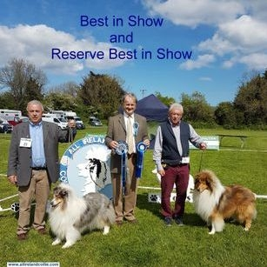
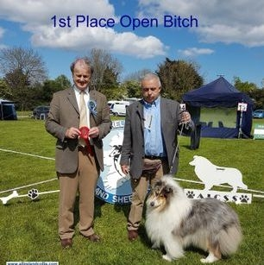
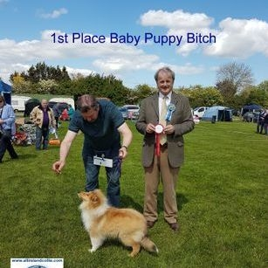
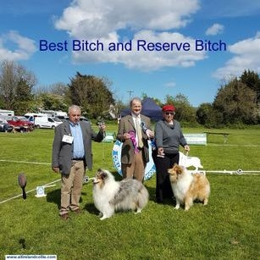
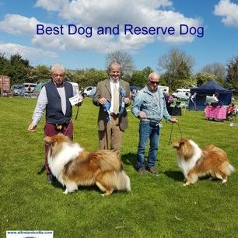

2018 News

Trefoil Gathering Photos by Noel Beggs

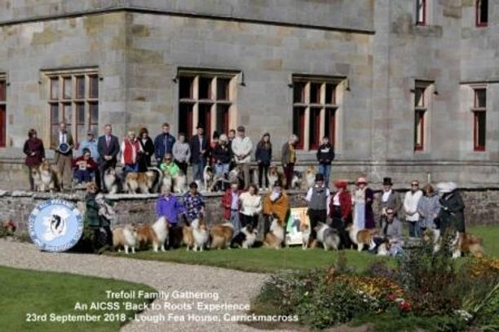
Rough Collies and Smooth Collies gathered to celebrate their common ancestor - Trefoil - born 1873 in Lough Fea, Carrickmacross.
The AICSS organised a Family Gathering on 23rd September 2018

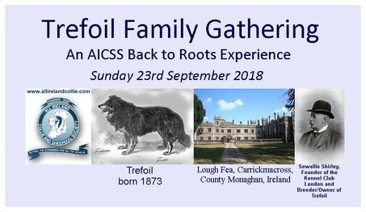

23rd September 2018

New Champion 2018

Congratulations to Karen McDevitt whose Ch Caronlea Charlie Brown gained his title at Clonmel 2018

Competition Winners of 2018
~AICSS Green Star Dog of the Year 2018
Karen McDevitt's Caronlea Charlie Brown

>AICSS Green Star Bitch of the Year 2018
Mary McNally's Ch Copamage Lily Langtree JunCh

>AICSS Puppy/Junior of the Year 2018
Eamon and Suzie Nealon's Ezzmare King of Hearts JunCh

>AICSS Circuit Points Competition 2018
JOINT WINNERS: Sean O'Briain's Seanchrois Fionnbarra an Ghugain AND Karen McDevitt's Ch Caronlea Charlie Brown

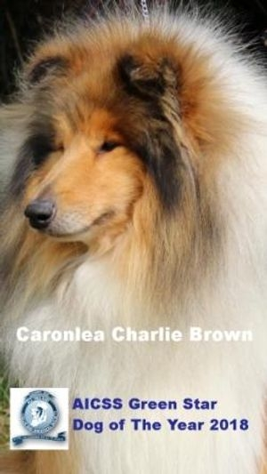
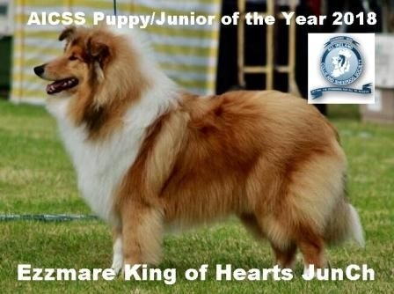
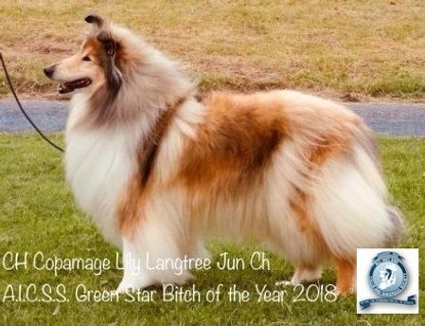
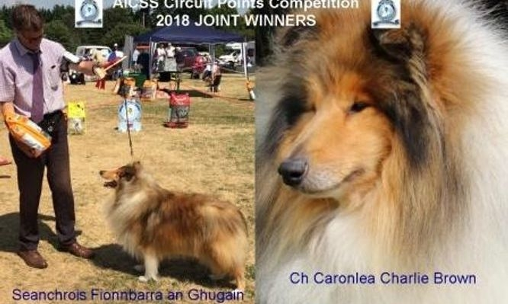

Champ Show July 2018
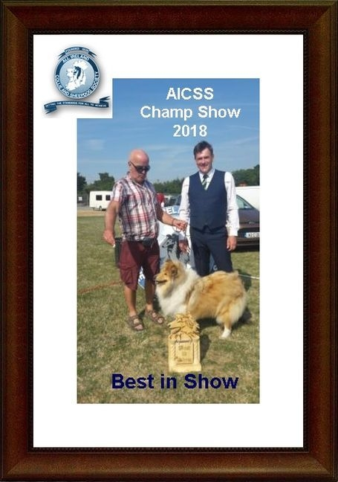
Club championship show July 2018.
Judge Tony Iley's results/critique on the Critiques page

New Champion 2018
Congratulations to Liam Hodson, whose dog Ch Moyhill King of Clubs gained his title at ILKA July 2018
Club Competitions for Club Members: GS Dog, GS Bitch and Pup/Jun of the Year 2018 points will be calculated from Clonmel last year up to and including Navan this year. The winners will be announced after Navan show on 19th August. NOTE that next year's competition starts with Sligo 2018 and will end with the club show July 2019. 🏆🏆🏆🏆 (can't avoid some overlap this year because of date change but will get back on track (y)) Good Luck to all competitors. Make sure that your membership is fully paid up 😉
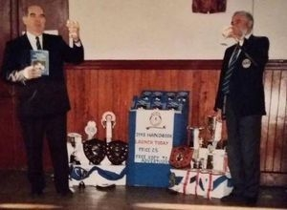
June 2018.
The death has taken place of Tony O'Neil, former IKC Secretary.
Pictured here (on the right) at the launch of our club handbook in 1994.
May he rest in peace
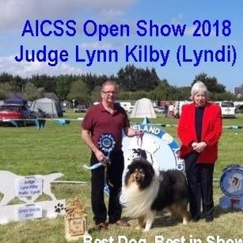
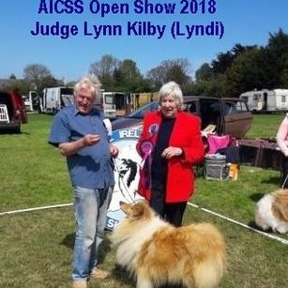
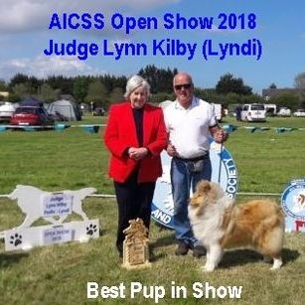
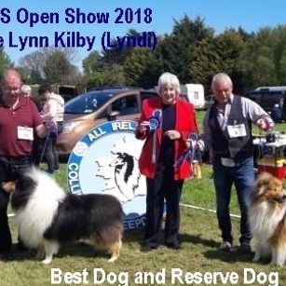
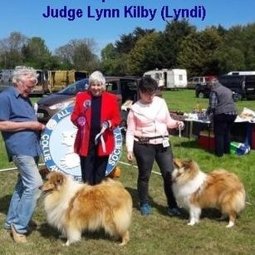
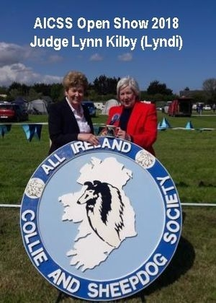
RESULTS
Breed Open Show 12th May 2018. Judge: Lynn Kilby (Lyndi)
• BEST DOG and BEST IN SHOW:- L Hodson. Moyhill Ace Of Clubs Jun Ch
• RESERVE DOG:- S Nealon. Eszmare Huggy Bear.
• BEST BITCH and RES BIS:- M Carr & M Colclough. Donohill Incognito
• RESERVE BITCH:- A Kelly. Evalane Sweet Fizzie Sherbet
• BEST PUP IN SHOW:- T Conway. Meryctin Sparkle Forever at Alwaycon

MINOR PUPPY DOG (3 entries)
1st L Hodson. Moyhill Red Rock
2nd M Carr & M Colclough. Donohill Spellbound
3rd R Jackson. Ladnar Mr Banks

PUPPY DOG (1 entry. 1 absent)
JUNIOR DOG (2 entries)
1st S Nealon. Eszmare Huggy Bear.
2nd T Wall, A Walsh. Hawksfield’s Return To Sender To Joshren At Daliyhaa

INTERMEDIATE DOG (3 entries. 1 absent)
1st S O’Briain. Seanchrois I’m The One.
2nd S Nealon. Ezzmare King Of Hearts Jun Ch

ADULT DOG. (1 entry. 1 absent)
OPEN DOG (2 entries)
1st L Hodson. Moyhill Ace Of Clubs Jun Ch
2nd M Delaney. Rowlands Gorgeous Gael Jun Ch

CHAMPION DOG (no entry)
VETERAN DOG (no entry)

MINOR PUPPY BITCH (2 entries)
1st D & M Timmins. Donohill Could This Be Magic for Kynan
2nd M Carr & M Colclough. Peblu Golden Classic

PUPPY BITCH (4 entries. 1 absent)
1st T Conway. Meryctin Sparkle Forever at Alwaycon
2nd D & M Timmins. Evalane Sugar Cotton Candy for Kynan
3rd S Drewery. Evalane Sticky Toffee Lollie

JUNIOR BITCH (6 entries. 1 absent)
1st A Kelly. Evalane Sweet Fizzie Sherbet
2nd M Carr & M Colclough. Rosschell Steal A Kiss
3rd M Delaney. Bonnettsrath Tararose
4th P Burridge. Bonnettsrath Tinkabella

INTERMEDIATE BITCH (2 entries. 2 absent)
ADULT BITCH (1 entry. 1 absent)
OPEN BITCH (6 entries. 2 absent)
1st M Carr & M Colclough. Donohill Incognito
2nd S Nealon. Riverside Song C’Est La Vie
3rd S O’Briain. Nystramenti Jewel Box at Seanchrois
4th T Wall. Daliyhaa Titch

CHAMPION BITCH (5 entries. 2 absent)
1st T Wall. Ch Birkmyre Blue Bouquet for Daliyhaa
2nd S Drewery. Ch, Int Ch Demelewis Fable Moon over Elshadene Vet Ch
3rd A Kelly. Ch Rowlands Abbie The Beautiful Lass

VETERAN BITCH (1 entry)
1st M McNally. Int Ch, Ch Roclynn Oksana of Copamage CJW10 Jun Ch
*********************************
JUNIOR HANDLING
1st Acer Bickmore, aged 8
TRICOLOUR
1st L Hodson. Moyhill Ace Of Clubs Jun Ch
SABLE & WHITE
1st P Burridge. Bonnettsrath Tinkabella
2nd L Hodson. Moyhill Red Rock
BRACE
1st Timmins. Donohill Could This Be Magic for Kynan AND Evalane Sugar Cotton Candy for Kynan

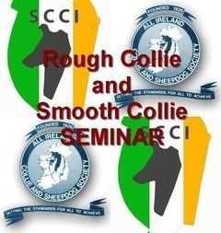
Seminar Download Details Book Places
Rough Collie and Smooth Collie Breed Specific IKC Accredited Module 4 Seminar
With support from the Smooth Collie Club of Ireland
Speaker: KC Accredited Trainer/Judge - Carole Smedley, Antoc
- Saturday 24th March 2018. 10 am start (registration 9.30 am)
- Venue: IKC National Show Centre, Cloghran, Co Dublin
- Free car parking. Tea/coffee on arrival. Light lunch included
Book early – there are limited places available for the Hands-on sessions
Book via our website https://www.allirelandcollie.com/apps/webstore/ (pay with PayPal)
Email Dermot Timmins at colliesociety@gmail.com Mobile 086 3327590
Module 4 Seminar only. Price €25
Hands on assessment for Rough Collies. €10 (limited places)
Hands on assessment for Smooth Collies. €10 (limited places)

Date Change for 2018 Champ Show
The AICSS breed championship show will now be held on Saturday 14th July 2018 - alongside ILKA.
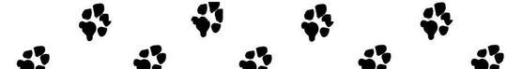

2017 news
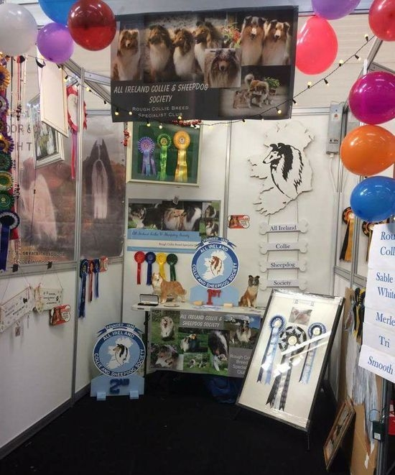
PET EXPO 2017

Showcasing the Rough Collie. The AICSS had a stand at this year's two day Pet Expo. Members brought collies along for the day and the dogs thoroughly enjoyed all the attention from the public.

New UK Champion
Congratulations to Karen McDevitt, whose dog Ch Caronlea Lukin Black JunCh, JCW16, CW17 gained his British champion title in October 2017 (subject to KC confirmation)

Competition Winners of 2017
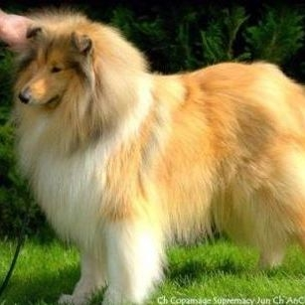
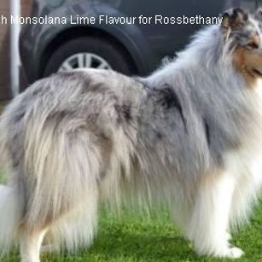
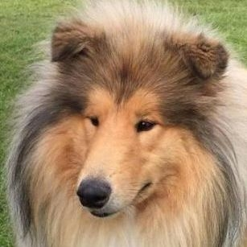
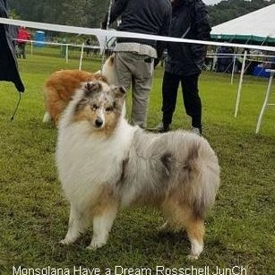
>~Green Star Dog of the Year 2017
Mary McNally's Ch Copamage Supremacy JunCh AnCh16 CW16 CJW16

>~Green Star Bitch of the Year 2017
Susan and Bethany King's Ch & Int Ch Monsolana Lime Flavour for Rossbethany

>~Puppy/Junior of the Year 2017
Marie Delaney's Ballahanna Let Battle Begin JunCh

>~Circuit Points Competition 2017
Michelle Davis and Jake Walsh's Monsolana Have a Dream Rosschell JunCh

Results

AICSS Breed Championship Show, August 2017. Judge: Mr Mac Shutt (Tapena)
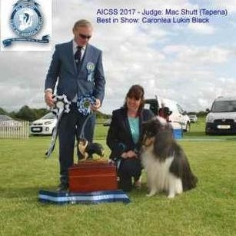
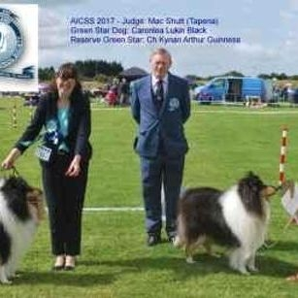
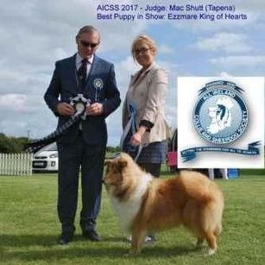
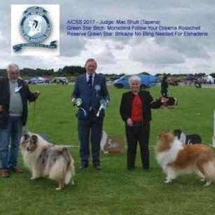
Green Star Dog & Best In Show; K Mcdevitt, Caronlea Lukin Black
Reserve Green Star: D & M Timmins, Ch Kynan Arthur Guinness
Green Star Bitch & Reserve Bis: M Carr & M Colclough, Monsolina Follow Your Dreams Rosschell
Reserve Green Star: S Drewery, Brikazie No Bling Needed For Elshadene
Best Pup In Show: S Nealon, Ezzmare King Of Hearts

Minor Puppy Dog
1st S Nealon, Ezzmare King Of Hearts
2nd K Mcdevitt, Caronlea Bond Ambition
Puppy Dog
1st S Nealon, Eszmare Huggy Bear
2nd S Bradley, Jakes Blue Boy Jake
Junior Dog
1st M Delaney Ballahanna Let Battle Begin
2nd S O’briain, Seanchrois I’m The One
Open Dog
1st K Mcdevitt, Caronlea Lukin Black
2nd M Carr And M Colclough, Donohill Nat King Cole
3rd M Delaney, Rowlands Gorgeous Gael
4th L Hodson, Moyhill Ace Of Clubs
Champion Dog
1st D & M Timmins, Ch Kynan Arthur Guinness
2nd M Mcnally, Ch Copamage Supremacy
Baby Puppy Bitch
1st M Davis, Rosschell Tia Of Illusion
2nd M Carr & M Colclough, Rosschell Steal A Kiss
Minor Puppy Bitch
1st K Mcdevitt, Caronlea Celtic Chick
2nd R Jackson, Ladnar Steppingstones
Puppy Bitch
1st S Nealon, Eszmare Too Sassy For You
Junior Bitch
1st M Davis, Monsolna Have A Dream Rosschell
2nd G Francis, Danfrebek Magical Kiss At Peblu
3rd S O’briain, Seanchrois Harmonious Blue Mist
Adult Bitch
1st M Davis, Old Golden Gates Francheska
Open Bitch
1st M Carr & M Colclough, Monsolina Follow Your Dreams Rosschell
2nd D & M Timmins, Ch Kynan Mika Blue Moon
3rd K Mcdevitt, Caronlea Pixie Chick
4th P Farrell, Monsolina Vorever Blue
Champion Bitch
1st P Farrell, Ch Monsolana Winter Taile At Belrah
2nd S Drewery, Ch & Int Ch Demelwis Fable Moon Over Elshadene
3rd M & N Magill, Ch Camanna Coloured Confetie At Beltra
4th S & B King, Ch Monsolana Lime Flavour Of Rissbethany
Veteran Bitch
1st S Drewery, Brikazie No Bling Needed For Elshadene
2nd M Mcnally, Ch & Int Ch Roclynn Oksana Of Copamage

New Champion in the breed 2017
Congratulations to Karen McDevitt, whose Ch Caronlea Lukin Black gained his title at the AICSS Champ Show in August 2017

New Champion in the breed 2017
Congratulations to Dermot and Maureen Timmins, whose Ch Kynan Mika Blue Moon gained her title at Sligo 2017

New International Champion in the breed 2017
Congratulations to Susan and Bethany King, whose Ch Monsolana Lime Flavour of Rossbethany gained her International title at Swords 2017

Important Information for Irish dogs being entered in UK shows
Press Release from UK Kennel Club..............
Amendments to Definition of Mid Limit and Limit Classes
20 June 2017 15:52
The Kennel Club has agreed amendments to the definition of the Mid Limit and Limit classes at breed shows, with effect from 1st January 2018.
The amendments are as follows:
Mid Limit – For dogs which have not become show Champions under Kennel Club Regulations or under the rules of any governing body recognised by the KC, or won 3 or more CC/CACIB/CAC/Green Stars or won 5 or more First Prizes in all at Championship Shows in Mid Limit, Limit and Open classes, confined to the breed, whether restricted or not, at Shows where CCs were offered for the breed.
[Amendment underlined.]
Limit – For dogs which have not become show Champions under Kennel Club Regulations or under the rules of any governing body recognised by the Kennel Club, or won 3 or more CC/CACIB/CAC/Green Stars or won 7 or more First Prizes in all at Championship Shows in Limit and Open Classes, confined to the breed, whether restricted or not, at Shows where Challenge Certificates were offered for the breed.
[Amendment underlined.]
Caroline Kisko, Kennel Club Secretary, said: “The SEC has noted that exhibits can have won three or more CCs, CACs, CACIBs or Green Stars without having qualified for a Champion title, whether they are resident in the UK or abroad. Therefore they were still able to qualify for Mid Limit and Limit classes giving them an unfair advantage over exhibitors whose dogs have been made Champions with the same number of awards. It is for this reason that these amendments have been brought in, to make these classes fairer for exhibitors.”
These amended class definitions will be reviewed by the SEC after they have been in operation for a period of 12 months.
ENDS

May 2017 - Breed Open Show, Judge Mick Fenton (Shannmie)
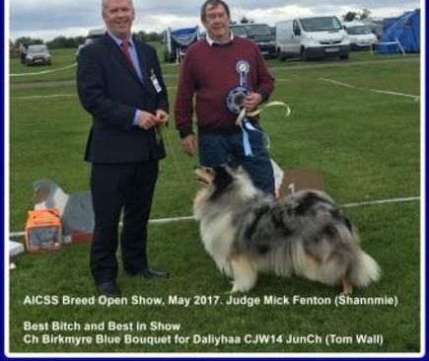
Best Bitch and Best in Show: Ch Birkmyre Blue Bouquet for Daliyaa (T Wall)
Best Dog and Res BIS: Moyhill Ace of Clubs (L Hodson)
Best Pup in Show: Ballahanna Let Battle Begin (M Delaney)
Reserve dog: Rowlands Gorgeous Gael (M Delaney)
Reserve bitch: Ch Rowlands Abbie The Beautiful Lass (A Kelly)

MORE PHOTOS OF THE SHOW

New Champion 2017
Congratulations to John and Carol Mulcahy, whose dog Ch Steadlyn Sunday Suit gained his title at Sth Tipp April 2017

New Champion 2017
Congratulations to Tom Wall, whose bitch Ch Birkmyre Blue Bouquet for Daliyhaa gained her title at Mid West April 2017

New Champion 2017
Congratulation to Susan and Bethany King, whose bitch Ch Monsolana Lime Flavour of Rossbethany gained her title at Banbridge April 2017

New Champion 2016
Congratulations to Sharon Drewery, whose bitch Ch Demelewis Fable Moon over Elshadene gained her title at IKC International Show November 2016.

2016

2016 Annual General Meeting
The AGM will be held on Tuesday 27th September 2016, 8 pm in the IKC National Show Centre, Cloghran, Co Dublin
Only fully paid up members may attend

Celebrating 90 years
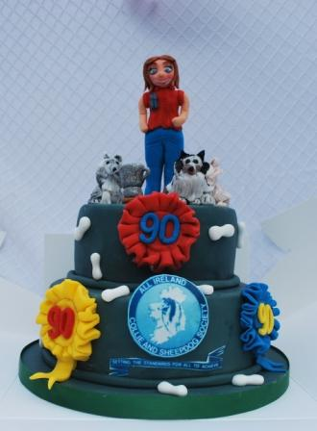

Results Champ Show August 2016 - Judge Jean Morgan (Tafton)
Green Star Dog: Ch Chantique Errol Flynn of Alwaycon (T Conway)
Reserve GS Dog: Caronlea Lukin Black JunCh (K McDevitt)
Green Star Bitch and Best in Show: Meryctin Brite Lika Diamond (J McIntyre & S McIntyre)
Reserve GS Bitch and Reserve BIS: Monsolina Vorever Blue (P Farrell)
Best Pup in Show: Meryctin Diamond Shimmer (J McIntyre & S McIntyre)
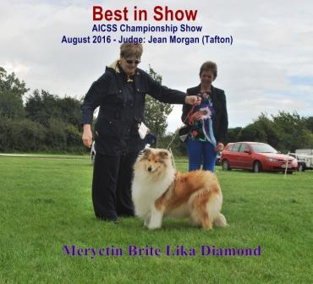 Critique 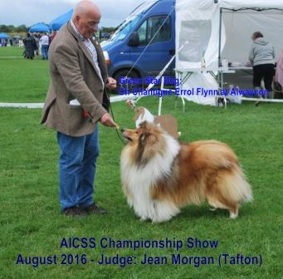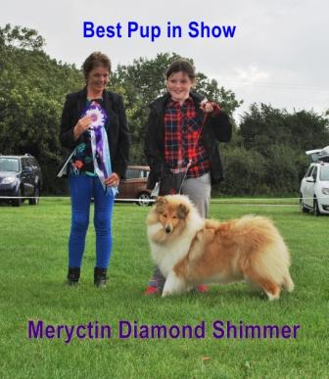
Minor Puppy Dog
1st Ware’s Wassail Mixed Blessing.

Junior Dog

Intermediate Dog
1st O’Brien’s Domlin Bruces Delights

Open Dog
1st Mc Devitt ‘s Caronlea Lukin Black
2nd Ware’s Rowlands Paddy McGinty at Wassail
3rd Timmins Kynan Arthur Guinness
4th Delaney's Rowlands Gorgeous Gael

Champion Dog
1st Conway’s Ch Chantique Errol Flynn of Alwaycon

Minor Puppy Bitch
1st Ware’s Wassail Mixed Spice
2nd Kelleher’s Verva Actis Poland

Puppy Bitch
1st McIntyre’s Meryctin Diamond Shimmer

Junior Bitch
1st Farrell’s Monsolina Vorever Blue

Intermediate Bitch
1st Delaney’s Bonnettsrath Mona Lisa
2nd Nealon’s Dun-Na Riogh Lass

Open Bitch
1st Mc Intyre’s Meryctin Brite Lika Diamond.
2nd Farrell’s Belrah Loves to Surprise.
3rd Mc Intyre’s Love is a Blonde at Lynmead
4th Timmins Kynan Mika Blue Moon

Champion Bitch
1st Timmins’ Ch Wassail China Blue at Kynan
2nd Kelly’s Ch Rowlands Abbie the Beautiful Lass

Veteran Bitch
1st Mc Devitt’s Caronlea Dixie Chick

New Champion 2016
Congratulations to Mary McNally, whose Ch Copamage Supremacy gained his title at Clonmel show August 2016

Club Competition Winners of 2016
AICSS Green Star Dog of The Year 2016: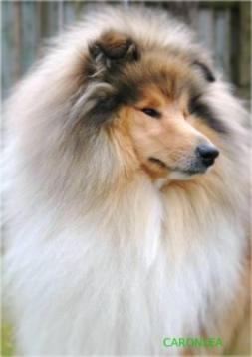
Ir, GB & Int Ch Caronlea Lord of the Dance AnCh 14 JunCh - owned and bred by Karen McDevitt

AICSS Green Star Bitch of The Year 2016:-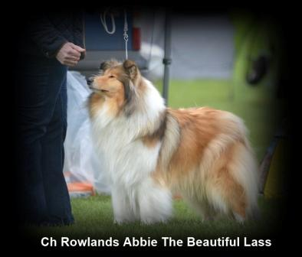
Ch Rowlands Abbie The Beautiful Lass - owned by Averil Kelly, bred by Eileen Seale

AICSS Puppy/Junior of The Year 2016:-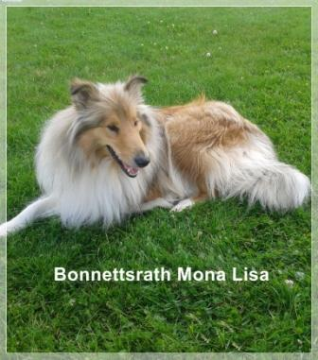
Bonnettsrath Mona Lisa - owned and bred by Marie Delaney
The President's Cup Circuit Points Competition 2016:-
Bonnettsrath Mona Lisa - owned and bred by Marie Delaney

New Champion 2016
Congratulations to Dermot and Maureen Timmins, whose Ch Kynan Arthur Guinness gained his title at Coleraine show August 2016

New Champion 2016
Congratulations to John and Carol Mulcahy, whose Ch & Aust Ch Kazjs Dancin Inthestars gained her title at Monkstown Dun Laoire show July 2016
KAZJS DANCIN INTHESTARS AUS CH

Parade of Irish Champions 2016
As part of our 90th Anniversary celebrations, we’re holding a Parade of Irish Champions at the 20th August champ show.
The charge is €3 to enter a champion. Each champion present will receive a special rosette and their photo will appear on the website. There will be a printed list of all entrants in the catalogue.

The closing date for entry for the Parade is Monday 1st August. Please send the Champion’s name, either by post or by email to either colliesociety@gmail.com OR colliesociety@yahoo.com.

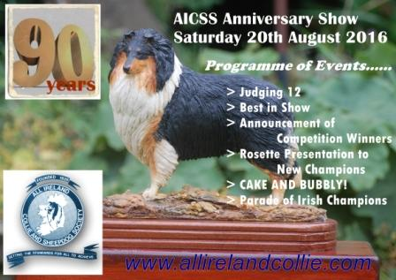

New Champion in 2016
Congratulations to Averil Kelly, whose Ch Rowlands Abbie the Beautiful Lass gained her title at BSD show June 2016

Enter Online at www.dogshowentry.ie
The club show can be entered online - (schedule)
online entries close Friday 5th August 2016.

Judge Critique
Tracey Goodwin's critique is now on the Critique page

New Champion in 2016
Congratulations to Peter Farrell, whose Ch Belrah Suprise gained her title at Munster Can, June 2016

New Champion in 2016
Congratulations to June Wall and Noel Beggs, whose Ch Kynan Mr Blue Sky at Everready gained his title at Cork & Dist, June 2016

May 2016
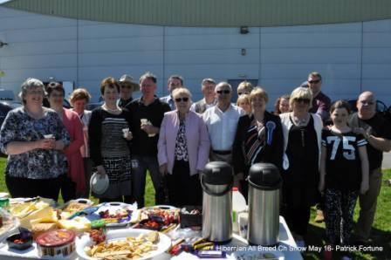

90th Anniversary Champ Show - May 2016
Judge Tracey Goodwin (Saheltra)
Green Star Dog & Best in Show: Ch Chantique Errol Flynn of Alwaycon (T Conway)
Reserve Dog: Moyhill Ace of Clubs (L Hodson)
Green Star Bitch & Reserve BIS: Kynan Mika Blue Moon (D & M Timmins)
Reserve Bitch: Durham Mistaken Identity at Donohill (M Carr & M Colclough)
Best Pup in Show: Donohill Incognito (M Carr & M Colclough)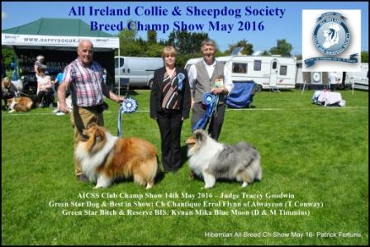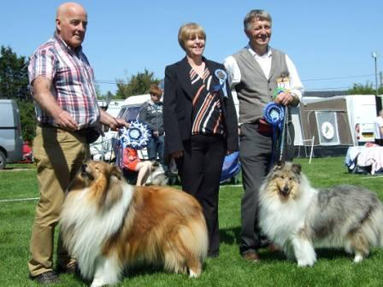

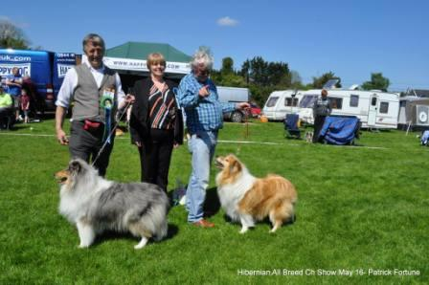
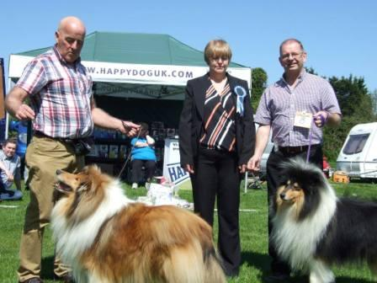
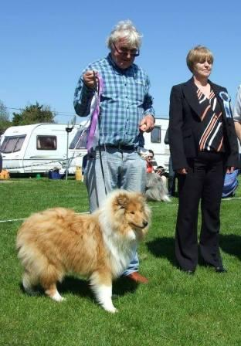

Class 1 - Baby Puppy Dog or Bitch (No entry)

Class 2 - Minor Puppy Dog (1)
1st Maurice Carr & Mary Colclough. Donohill Mcintyre..

Class 3 - Puppy Dog (1) 1 absent

Class 4 - Junior Dog (1)
1st Dominick & Linda O’Brien. Domlin Bruce Delight .

Class 5 -Intermediate Dog (1) 1 absent

Class 6 - Open Dog (6) 2 absent
1st Liam Hodson. Moyhill Ace of Clubs JunCh (Res GS)
2nd Dermot & Maureen Timmins. Kynan Arthur Guinness -
3rd Michael Collins/Marie Delaney. Rowlands Gorgeous Gael.
4th John And Carol Mulcahy. Steadwyn Sunday Suit –

Class 7 - Champion Dog (2)
1st Thomas Conway. Ch Chantique Errol Flynn (Green Star & BIS)
2nd Liam Kelly. UK Ch Clowns Come On Over To Ballahanna

Class 8 - Veteran Dog (1) 1 absent

Class 9 - Children’s Handling Class Age 8 to 11
1st Aleesha Mcintyre
2nd Lucia Bradley
3rd Grace Bradley

Class 10 - Children’s Handling Class Age 12 to 14 (no entry)
Class 11 - Junior Handling Class Age 15 to 18 (no entry)

Class 12 -Minor Puppy Bitch (2)
1st Maurice Carr & Mary Colclough. Donohill Incognito (Best Pup in Show)
2nd Maria Trainor. Gramollace Molly Malone

Class 13 - Puppy Bitch (1)
1st J & C Mulcahy. Kazjs Simply Irresistible.

Class 14 - Junior Bitch (3) 1 absent
1st Thomas Conway. Riverside Song C'est La Vie
2nd Marie Delaney. Bonnettsrath Mona Lisa.

Class 15 - Intermediate Bitch (2)
1st Norman & Marie Magill. Camanna Cloudy with a Chance for Beltra.
2nd Sharon Drewery. Moonkisses From Ever After ( Import) Cze.

Class 16 - Open Bitch (12) 5 absent
1st Dermot & Maureen Timmins. Kynan Mika Blue Moon. (Green Star & Res BIS)
2nd Maurice Carr & Mary Colclough. Durham Mistaken Identity At Donohill (Res GS)
3rd Grenville Francis. Ileyda Satin Lace of Peblu.
4th Averil Kelly. Rowlands Abbie The Beautiful Lass

Class 17 - Champ Bitch (1) 1 absent

Class 18 - Veteran Bitch (2) Rosettes sponsored by Susan and Bethany King (Rossbethany)
1st Sharon Drewery. Brikazie No Bling Needed For Elshadene
2nd Lisa & James Finnegan. Oakmoon Lady Madonna.

Ted's retirement
I'm sad to tell you all that Ted won't be stewarding at our club shows in the future. He has decided to hang up his steward's pen and retire. On your behalf, I'd like to thank Ted for all the years of service to the Society. He'll be sorely missed.
Of course we recently lost our other wonderful steward - Bill - so the shows will definitely not be the same. But the club is resilient - and the shows must go on.
A really nice photo of Ted and Bill "super stewards at work" will be on the judge's table this weekend.
I'd like to wish Irene and the other committee members all the best for the future - I know you'll do the club proud.
regards, Maureen

Club Secretary
3rd May 2016. I'm stepping down as Club Secretary, and leaving everything in the capable hands of Irene Grant – (our assistant secretary/show secretary). So from today Irene is taking over as Club Secretary and all club business can be directed to her. I’ve enjoyed being Club Secretary since the early 90s (apart from one year off) and now I'm going to enjoy not being Club Secretary. Best regards, Maureen

Collie Chat magazine 2016
Members will receive their FREE copy of Collie Chat along with the schedule for our May show in the post soon. Remember, you can download your schedule HERE and enter online HERE

New Champion for 2016
congratulations to Paul Battigan, whose bitch Ch Angie's Angels Amazara of Roclynn gained her title at Combined Canine National, March 2016

New International Champion 2016
Congratulations to Mary McNally whose Ch Roclynn Oksana Of Copamage Cjw10 JunCh gained her International title at Combined Canine, March 2016

ikc Dog Expo 17th March 2016
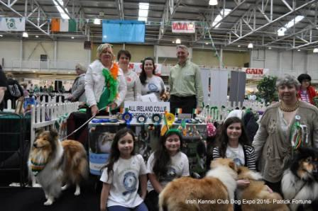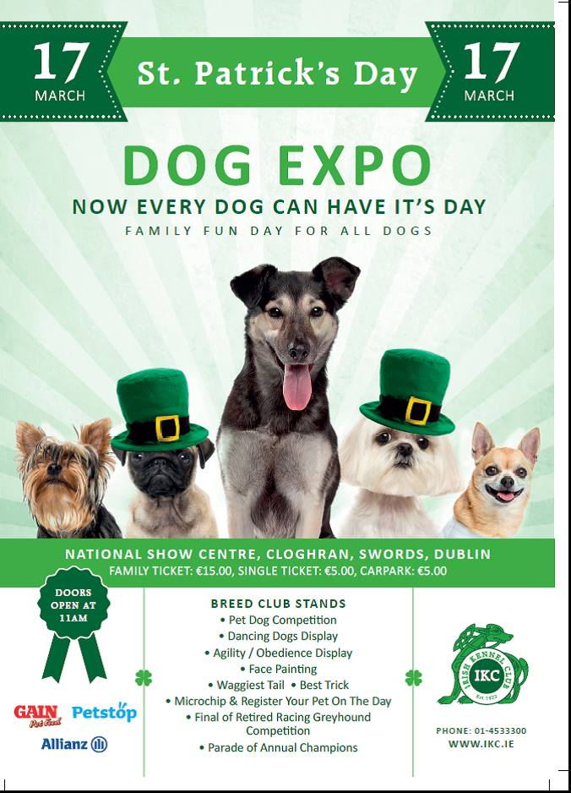

May 2016 Champ Show
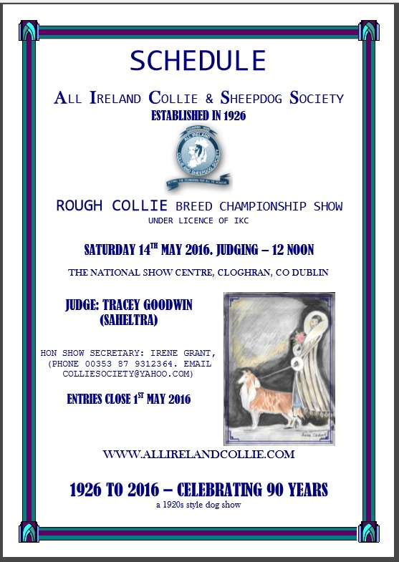

Crufts 2016
Liam Kelly's dog - Clowns Come On Over to Ballahanna won the CC and Best of Breed at Crufts

show info
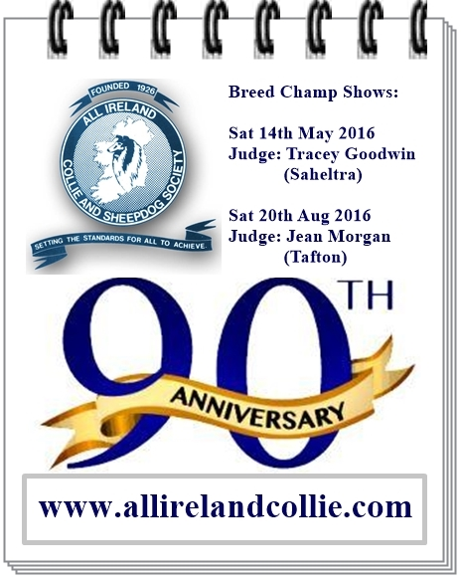

2015

Two AICSS Champ Shows for 2016!
our club was founded in 1926 - and we will be celebrating our 90th anniversary in 2016.
We are delighted to announce that as part of the celebrations we will be running not one, but TWO champ shows in 2016!

Our show dates for the coming year are as follows:-

(1) Breed Champ Show - Saturday 14th May 2016 - (in conjunction with Hibernian) judge: Tracey Goodwin (Saheltra) subject to ikc approval
(2) Breed Champ Show - Saturday 20th August 2016 - (in conjunction with Navan) judge: Jean Morgan (Tafton)

Rest in Peace Bill McIntyre
Honorary Life Member, Bill McIntyre, passed away on 2nd December. A loyal member and a good friend to the club, Bill will be sadly missed
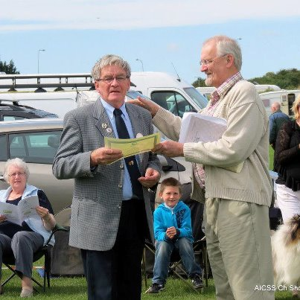

New Champion 2015
Congratulations to Tommy Conway, whose dog Chantique Errol Flynn at Alwaycon gained his title at Bull Breeds October 2015

2016 Committee

President: Dermot Timmins
Vice President and Chair: Liam Hodson
Assistant Chair: Marie Delaney
Club Secretary: Maureen Timmins 0863327590. Email colliesociety@yahoo.com
Assistant Secretary and Show Secretary: Irene Grant
Treasurer: Averil Kelly
Committee: George Kerslake, Peter Farrell, Lynn Kilby, Dominick O'Brien, Sean O'Briain, Maria Trainor
IKC Ard Chomhairle Reps: Dermot Timmins, Maureen Timmins

Results of 2015 Champ Show
RESULTS AICSS Breed Champ Show 15th August 2015
Judge: Roz Makepeace (Lynaire)

o Green Star Dog and Reserve Best in Show:
Thomas Conway. Chantique Errol Flynn of Alwaycon
o Reserve Green Star Dog:
Dermot & Maureen Timmins. Kynan Arthur Guinness
o Green Star Bitch and Best in Show:
Peter Farrell. Monsolana Winters Taile at Belrah JunCh
o Reserve Green Star Bitch:
Marie Magill. Ch Camanna Coloured Confetie at Beltra JunCh ShCm
o Best Puppy in Show:
Karen McDevitt. Caronlea Pixie Chick

§ Class 1—Baby Puppy Dog or Bitch NO ENTRIES

§ Class 2—Minor Puppy Dog (1 entry)
1st Dominick & Linda O’Brien. Domlin Bruce Delight.

§ Class 3—Puppy Dog (2 entries, 1 absent)
1st Mary McNally. Copamage Supremacy.

§ Class 4—Junior Dog (1 entry, 1 absent)

§ Class 5—Intermediate Dog (4 entries, 1 absent)
1st Dermot & Maureen Timmins. Kynan Arthur Guinness.
2nd Karen McDevitt Caronlea Lukin Black JCW15 JunCh.
3rd Maurice Carr & Mary Colclough. Donohill Black Caviar.

§ Class 6—Open Dog (10 entries, 2 absent)
1st Thomas Conway. Chantique Errol Flynn of Alwaycon
2nd Liam Kelly. Clowns Come on Over to Ballahanna
3rd Liam Hodson. Moyhill Ace of Clubs
4th Noel Beggs & June Wall. Kynan Mr Blue Sky at Everready.

§ Class 7 – Champion Dog (3 entries)
1st Karen McDevitt Ch, Int Ch,GB Ch Caronlea Lord of The Dance AnCh14 JunCh
2nd A Hollywood & C Waterhouse. Ch Amalie Lynmead Love to Hug AnCh12 CJW12 CW12&13.
3rd John & Carol Mulcahy. Ire/Aust Sup Ch Kazjs Sir Spense

§ Class 8 – Veteran Dog (no entries)

§ Class 9 – Children’s Handling age 8-11 (no entry)

§ Class 10 – Children’s Handling age 12-14 (2 entries, 1 absent)
1st Sean Ralph

§ Class 11 – Junior Handling age 15-18 (1 entry)
1st Mark McGurk

§ Class 12 – Minor Puppy Bitch (1 entry)
1st Thomas Conway. Riverside Song C’Est La Vie

§ Class 13 – Puppy Bitch (3 entries)
1st Karen McDevitt. Caronlea Pixie Chick
2nd Marie & Norman Magill. Camanna Cloudy with a Chance for Beltra
3rd Maurice Carr & Mary Colclough. Donohill Magic and Sparkle

§ Class 14 – Junior Bitch (2 entries, one absent)
1st Mark McGurk. Caronlea Bella Devine

§ Class 15 – Intermediate Bitch (2 entries)
1st Dermot & Maureen Timmins. Kynan Mika Blue Moon
2nd Maurice Carr & Mary Colclough. Donohill Madiba Blu

§ Class 16 – Open Bitch (14 entries, 4 absent)
1st Peter Farrell. Monsolana Winters Taile at Belrah JunCh
2nd Karen McDevitt. Caronlea Dixie Chick JunCh
3rd Peter Farrell. Belrah Popcorn Surprise
4th Catherine Byrne. Millbyrne Returns with Lottie JunCh

§ Class 17 – Champion Bitch (2 entries, 1 absent)
1st Marie Magill. Ch Camanna Coloured Confetie at Beltra JunCh ShCm

§ Class 18 – Veteran Bitch (1 entry)

1st Sharon Drewery. Brikazie No Bling Needed for Elshadene

New Champion 2015
Congratulations to Peter Farrell, whose Monsolana Winter's Taile at Belrah gained her Champion title at the club show in August.

Club Champ Show 15th August 2015 - Judge Roz Makepeace (Lynaire)

Club Competition Winners of 2015
AICSS Green Star Dog of The Year 2015:-
Ir, GB & Int Ch Caronlea Lord of the Dance AnCh 14 JunCh - owned and bred by Karen McDevitt
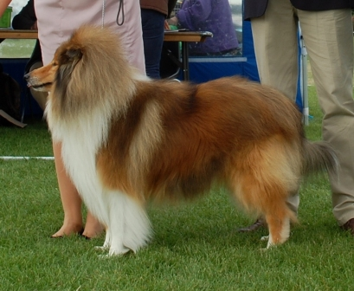
AICSS Green Star Bitch of the Year 2015:-
Ch Monsolana Winter's Taile at Belrah, owned by Peter Farrell
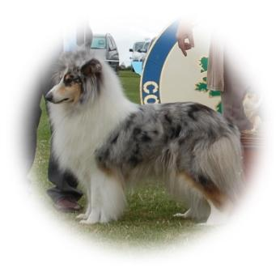
AICSS Pup/Junior of the Year 2015:-
Caronlea Lukin Black CJW15 JunCh, owned and bred by Karen McDevitt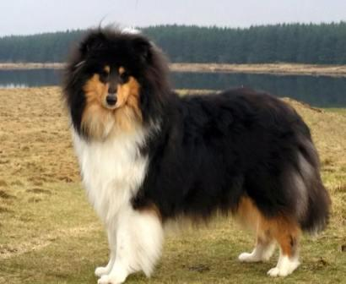
Circuit Points Trophy 2015:- Joint Winners.............
Ir, GB & Int Ch Caronlea Lord of the Dance AnCh 14 JunCh (K McDevitt)
AND
Copamage Supremacy (M McNally)
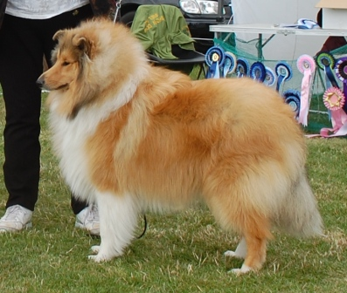
(above) Copamage Supremacy

(above) Ir, GB & Int Ch Caronlea Lord of the Dance AnCh 14 JunCh

Club Open Show 16th May 2015
Judge Liam Kelly (Ballahanna) (Check back here soon for critique)
Best Bitch & Best in Show: P Farrell's Monsolona Winters Taile at Belrah.
Reserve Bitch: S Drewery’s Brikazie No Bling Needed For Elshadene
Best Dog & Reserve BIS: I Cummings’ Altnareagh I’m Tozer
Reserve Dog: M Carr & M Colclough’s Donohill Black Caviar

Best Puppy in Show: M Carr & M Colclough’s Donohill Magic and Sparkle

Newcomer of The Year Competition
New for 2015 - a competition to encourage new members to show their dogs. Read all about it here.
View the Rules here

New Champion 2015
Congratulations to Paul Battigan, whose champion Myafreya Gold of Roclynn gained her title at Combined Canine

New Champion 2014
Congratulations to Tom Wall whose champion Birkmyre Blue Diamond for Daliyhaa gained her title at Cloghran

New International Champion
Congratulations to Karen McDevitt whose Irish Champion Caronlea Lord of The Dance gained his FCI International title at IKC show in October 2014

Club Champ Show 2014 - Judge: Wm Ritchie (Aberquarie)
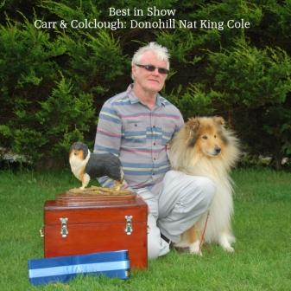click here for critique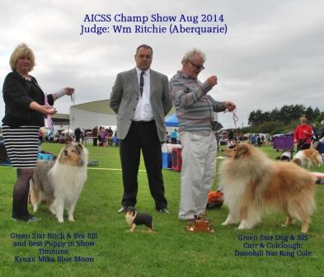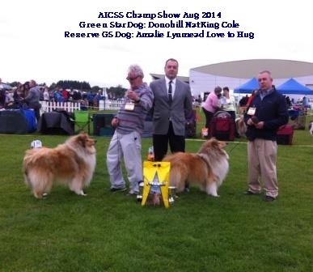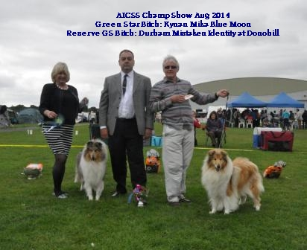
AICSS Champ Show. Judge Wm Ritchie (Aberquarie)

- Green Star Dog & Best in Show: Maurice Carr & Mary Colclough's Donohill Nat King Cole.
- Reserve Dog: A Hollywood & C Waterhouse Ch Amalie Lynmead Love to Hug.
- Green Star Bitch & Res BIS Dermot & Maureen Timmins' Kynan Mika Blue Moon.
- Reserve Bitch Carr & Colclough's Durham Mistaken Identity at Donohill
- Best Puppy in Show: Dermot & Maureen Timmins' Kynan Mika Blue Moon

Club Competition Winners 2014
Green Star Dog of the Year 2014: Ch & UK Ch Caronlea Lord of the Dance JunCh (Karen McDevitt)
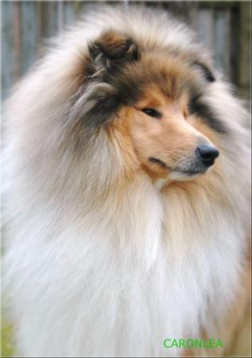

Green Star Bitch of the Year 2014: Ch Copamage Elisadoolittle at Millbyrne JunCh (Catherine Byrne)
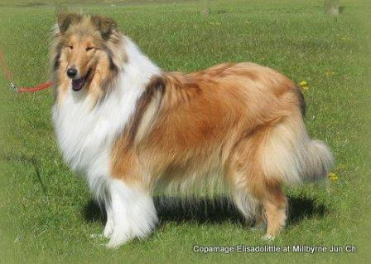
Puppy/Junior of the Year 2014: Birkmyre Blue Bouquet for Daliyhaa (Thomas Wall)
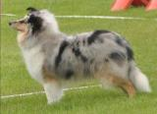
The Circuit Points Trophy 2014: Rowlands Gorgeous Gael (Michael Collins/Marie Delaney)


Closing 1st Aug
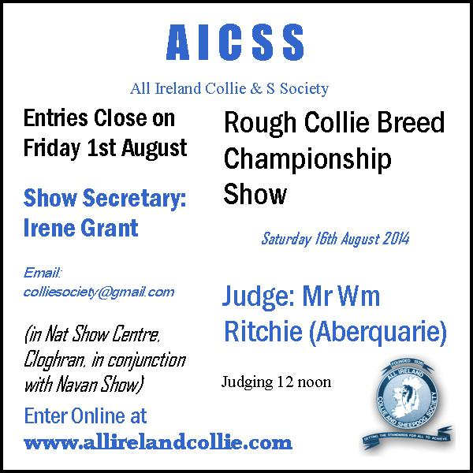

Critique - May 2014
Judge's critique from Irene Grant is now on the Critiques page

New Champion 2014
Congratulations to Catherine Byrne whose bitch Copamage Elisadoolittle at Millbyrne Jun Ch gained her title at Cork & District, June 2014

Club Open Show May 2014 - Judge Irene Grant (Marcolem)
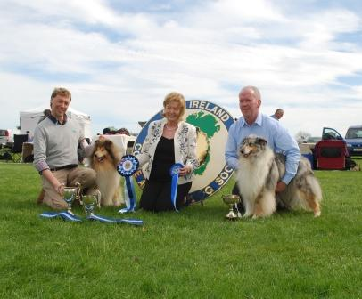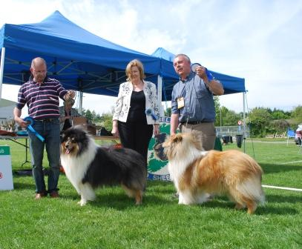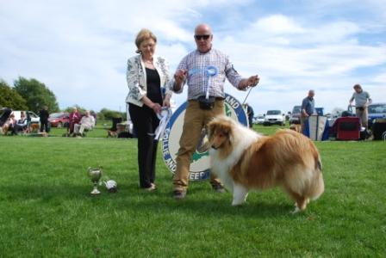
Baby puppy dog or bitch – no entry

Minor puppy dog (2) – 2 absent

Puppy dog (1)
1st T Conway – Chantigue Errol Flynn of Alwaycon (BEST PUPPY IN SHOW)

Junior dog (3) – 2 absent
1st M Carr & M Colclough – Donohill Back from the Bronx

Intermediate Dog – no entry

Open Dog (9) - 3 absent
1st Liam Hodson – Moyhill Ace of Clubs JunCh (BEST DOG)
2nd Susan Watkinson – Wassail Into the Rough at Tegan
3rd – Maurice Carr & Mary Colclough – Donohill Nat King cole
4th – Joe & Mary Ball – Durham Lady’s King

Champion Dog (1)
1st Hollywood & Waterhouse – Ch Amalie Lynmead Loves to Hug (RESERVE DOG)

Junior Handling age 12 to 14
1st Sean Ralph

Minor Puppy Bitch (1) – 1 absent

Puppy Bitch – no entry

Junior Bitch (6) – 3 absent

1st Averil Kelly – Rowlands Abbie The Beautiful Lass
2nd Thomas Wall – Birkmyre Blue Bouquet
3rd Susand & Bethany King – Monsolana Lime Flavour of rossBethany

Intermediate Bitch (2)

1st Eileen Seale – Rowlands Blaithin Beag
2nd Susan Watkinson – MacOrtofts Rose For My Life at Wassail

Open Bitch (12) – 2 absent

1st Paul Battigan – Myafreya Gold of Roclynn (BEST BITCH & BEST IN SHOW)
2nd Thomas Wall – Birkmyre Blue Diamond (RESERVE BITCH AND RES BIS)
3rd Peter Farrell – Belrah Popcorn Surprise
4th Dominick & Lynda O’Brien – Belrah Maggies Delight at Domlin

Champion Bitch – no entry

Veteran Bitch – no entry

IKC Annual Champion 2013
Rough Collie Annual Champion of 2013 is Ch Wassail China Blue at Kynan AnCh13 CJW13 CW13 JunCh - owned by Dermot & Maureen Timmins

Gain/Our Dogs Ireland Competition
GAIN/Our Dogs Ireland Top Breeder Competition 2013 based on wins by dogs bred by kennels, The Rough Collie top breeder winner is Mary McNally, Copamage

Collie wins Group three times and BIS twice in 2013
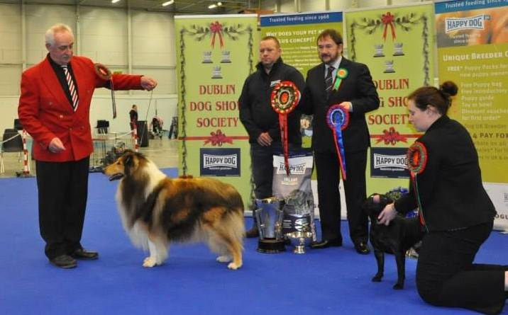Congratulations to John and Carol Mulcahy whose dog Australian Supreme Grand Ch Kazjs Sir Spense had huge success at All Breed shows this year

New Champion 2013
Congratulations to John and Carol Mulcahy whose dog Australian Supreme Grand Ch Kazjs Sir Spense gained his Irish title at Cloghran Nov 2013

Critique from 2013 Champ Show
Janet James' critique now on the Club Show Critique page click here

2014 Committee
President: Dermot Timmins
Vice President: Liam Hodson
Chair: George Kerslake
Vice Chair: Joe Ball
Hon Secretary: Maureen Timmins
Assistant Secretary: Deirdre Mitchell
Committee: Peter Farrell, Mary Ball, Dominick O'Brien, Lynn Kilby, Sean O'Briain
ikc Ard Chomhairle Reps: Dermot Timmins and Maureen Timmins

Club Competition Winners 2013
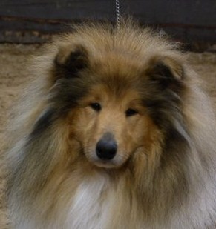
Green Star Dog of the Year 2013:
- Anne Hollywood & Caz Waterhouse's Ch Amalie Lynmead Loves to Hug (shown by Peter Farrell)

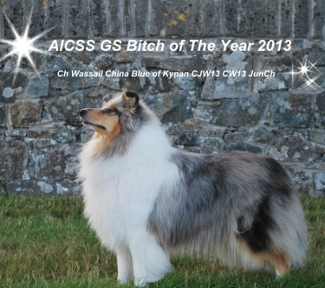
- Green Star Bitch of the Year 2013:
- Dermot & Maureen Timmins' Ch Wassail China Blue at Kynan

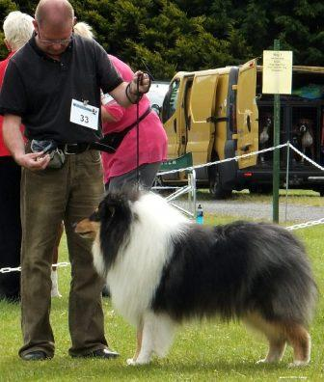

- Puppy/Junior of the Year 2013:
Liam Hodson's Moyhill Ace of Clubs

Circuit Points Competition 2013:
Tom Wall's Birkmyre Blue Bouquet

Club Champ Show 17th August 2013
Judge: Janet James (Deanjan)
Green Star Bitch & Best In Show: Ch Belrah Simply Surprise (Peter Farrell)
Green Star Dog & Res BIS: Ch Caronlea Lord of the Dance (Karen McDevitt)
Res dog: Ch Amalie Lynmead Loves to Hug (Hollywood & Waterhouse), Res bitch: Starlenga Mysterious Girl at Forrestwalk (I Ashe)
Best Pup in Show: Birkmyre Blue Bouquet (Wall)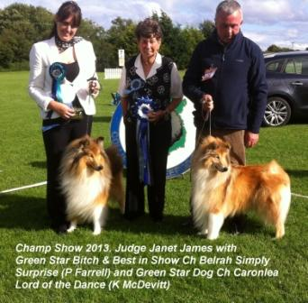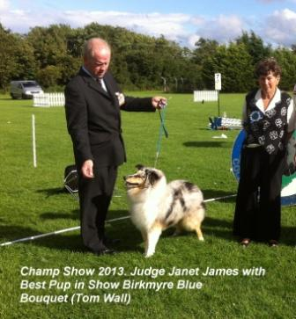

www,collielife.com
Collielife are sponsoring our forthcoming Champ Show - read about it here

New Baby
On behalf of the members of the AICSS, huge congratulations are offered to one of our Hon Life Members, Paul Battigan, on the birth of his and Elaine’s beautiful son Nathan Carl. We look forward to the time when Nathan will show his first collie in the junior handling class

New Champion 2013
Congratulations to Dermot & Maureen Timmins - whose bitch Wassail China Blue at Kynan JunCh CW13 CJW13 gained her champion title at Deise Show June 2013

New Champion 2013
Congratulations to Marie Magill - whose bitch Camanna Coloured Confetie at Beltra gained her champion title at Kilkenny Show June 2013

11th May 2013 Club Open Show
Judge: Flora Denning (Baylands)
Best Bitch and Best in Show:
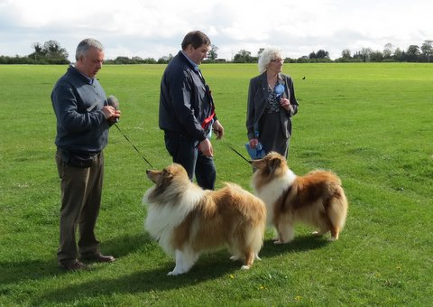
Ballahanna Beyonce (Liam Kelly)
Best Dog and RBIS
Ch Amalie Lynmead Love to Hug (A Hollywood & C Waterhouse)

(Reserve Bitch: Durham Mistaken Identity at Donohill, Carr & Colclough)
(Reserve Dog: Samhaven No Limits, Kelly & Grainger)

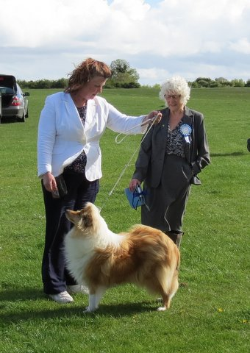

Best Puppy in Show:

MacOrtofts Rose For My Life at Wassail, Di Ware

New Champion 2013
Congratulations to Deirdre Mitchell, whose dog Chopard Soulstar Jun Ch gained his title at Fermoy Int Show May 2013

17th March 2013, IKC National Show Centre, Cloghran
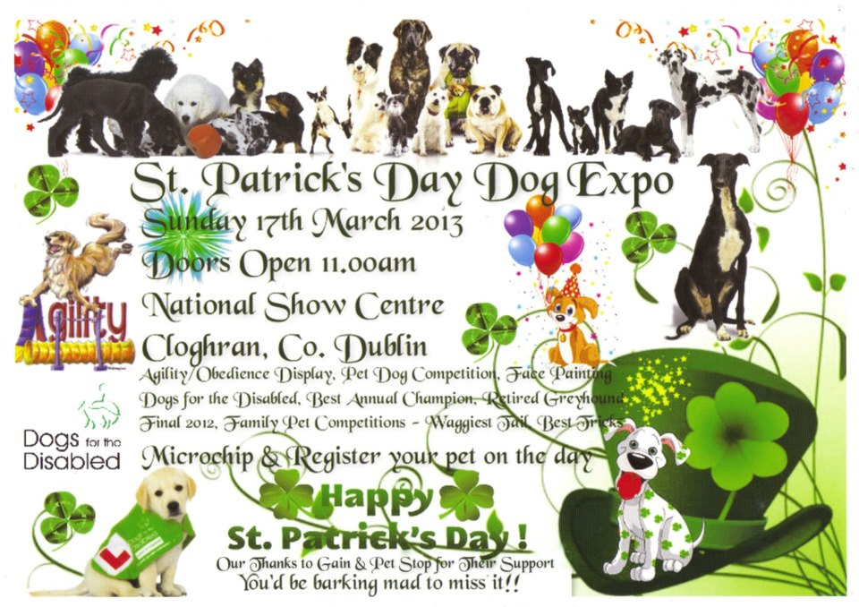

New Champion 2012
Congratulations to Michele Davis, whose bitch Ch Rosschell Blue Crystalball JunCh gained her title at Dublin Dog Show on 27/12/12

AGM 6th October 2012

AGM report: The 2013 committee will be:
President: Dermot Timmins
Vice President: Liam Hodson
Chair: Deirdre Mitchell
Vice Chair: Di Ware
Secretary: Maureen Timmins
Assistant Secretary: Di Ware
Treasurer: Mary McNally
Committee: Catherine Byrne
IKC Ard Chomhairle Reps: D Timmins & M McNally

New Champion 2012
Congratulations to Mary McNally, whose bitch Ch Copamage Lily Langtree Jun Ch, gained her title at Carlow All Breed Champ show Sept 2012

2012 Club Competitions
Green Star Dog of The Year 2012:
Amalie Lynmead Loves to Hug (A Hollywood & C Waterhouse)
Green Star Bitch of the Year 2012:
Ch Roclynn Oksana at Copamage (M McNally)
Puppy/Junior of the Year 2012:
Wassail Lidiya at Kynan (D & M Timmins)
Circuit Points Competition 2012:
Copamage Lily Langtree Jun Ch (M McNally)

18th August 2012 Club Champ Show
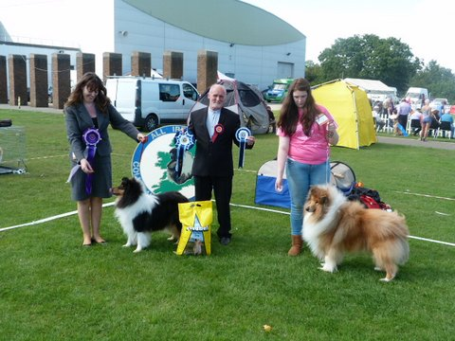  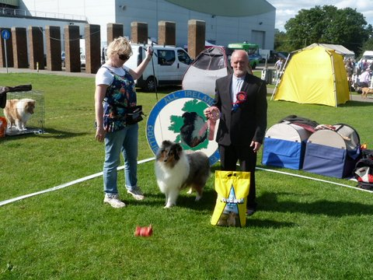 | Judge: John Congdon (Aaronwell)  Green Star Bitch & Best in Show:  Caronlea Dixie Chick (Karen O'Neill)  Green Star Dog & Res BIS:  Durham Lady's King (Joe & Mary Ball, handled by Michelle Ball)  Best Puppy in Show:  Rosschell Blue Mojito at Donohill (Maurice Carr & Mary Colclough)

New Honorary Life Member

we are delighted to announce that the committee proposed to grant Honorary Life Membership to Bill McIntyre (President of Ayrshire Collie Club) in recognition of his consistent support and work for our club. . Pictured is Bill being presented with a certificate of Hon Life Membership by Ted Bollard. 18th August 2012

Collie Wins Group at Navan August 2012
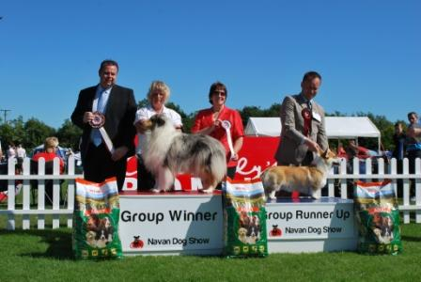
Rosschell Blue Crystalball (Michelle Davis)

New Champion 2012
Congratulations to Peter Farrell - who campaigned Ch Amalie Lynmead Loves To Hug, to his Irish title in July 2012. He is owned and bred by A Hollywood and C Waterhouse

title
Click to add text, images, and other content

New Champion 2012
Congratulations to Di Ware (owner) and Michelle Davis (breeder) - who's blue dog Ch Rosschell Bobby Dazzler at Wassail gained his title at Kilkenny, June 2012
Change of Date!
note: - due to circumstances completely beyond our control - we have to change the date of our 2012 Champ Show. The show will now be held on 18th August (in conjunction with Navan show). Show secretary Di Ware for all details

New Champion 2012
Congratulations to Mary McNally (owner) and Paul Battigan (breeder) - who's sable bitch Ch Roclynn Oksana at Copamage JunCh, gained her title in May 2012

12th May 2012 OPEN SHOW
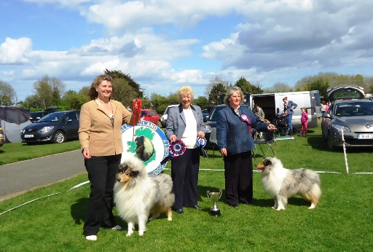
Judge: Naomi McDowall (Birkmyre)
Best Dog & BIS Rosschell Bobby Dazzler at Wassail (Di Ware)
Best Bitch & RBIS Rosschell Blue Crystalball (Michelle Davis)

Best Pup in Show Roclynn Private Ryan (Paul Batigan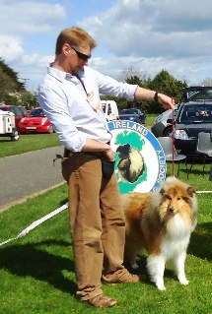

Committee
31/10/11 two new committee members are co-opted - Di Ware and Maria Trainer

Irish Kennel Club Ard Chomhairle Reps for 2012
Dermot Timmins and Mick Doyle

Officers and Committee for 2012
President: Dermot Timmins
Vice Pres: Liam Hodson
Chair: Deirdre Mitchell
Vice Chair: Joe Ball
Secretary: Maureen Timmins
Assist Sec: Joe Ball
Treasurer: Mary McNally
Committee: Angie Doyle, Mick Doyle, Steve Doyle

2011 Competition Winners
AICSS Green Star Dog of The Year 2011 -
Di Ware's Rosschell Bobby Dazzler at Wassail Jun Ch
AICSS Green Star Bitch of The Year 2011 -
Peter Farrell's Ch Belrah Simply Surprise
AICSS Puppy/Junior of The Year 2011 -
Deirdre Mitchell's Chopard Soulstar Jun Ch
Circuit Points Trophy 2011 (Presidents Cup) -
Mary McNally's Copamage Lily Langtree

AGM
The AGM will take place on Tuesday 4th October - 8 pm in Cloghran

Champ Show 28th August 2011
Judge Pat Hutchinson (Karibuni)
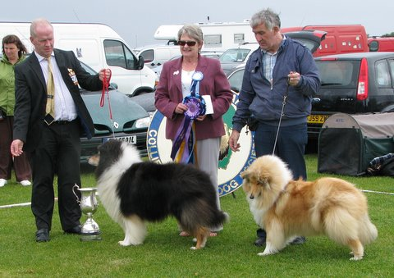
Green Star Dog & Best in Show - Tom Wall's Ch Countrys King Dream for a Day,
Reserve Dog - Joe Ball's Rosschell Kiss'n The Dark at Durham
Green Star Bitch & RBIS - Joe Ball's Beldones Take a Chance at Durham
Reserve Bitch - Di Ware's Ch & Int Ch Aloutte Bleu Des Margecages Du Prince

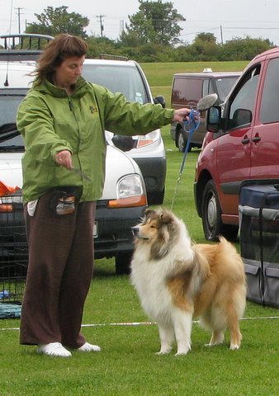
Best Puppy in Show - Di Ware's Wassail Tip Toe Franc

Open Show 15th May 2011
Judge Ted Bollard (Rhontar)
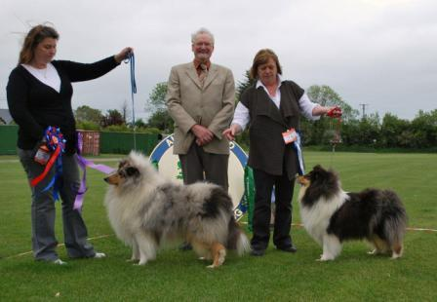
Best Dog and Best in Show - Di Ware's Rosschell Bobby Dazzler at Wassail Jn Ch. Best Bitch and RBIS - Di Ware's Wassail Lucy Locket Jn Ch
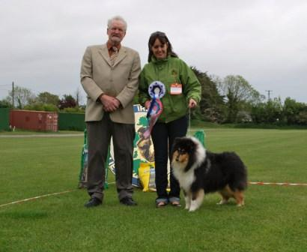
Best Puppy in show - Karen O'Neill - Caronlea Black with Envy
Reserve Dog: Catherine Byrne's Roclynn Orpheus at Millbyrne. Reserve Bitch:Ch. Amalie Surprise at Belrah
click for Judge's Critique

New International Champion
Congratulation to Di and Reg Ware, whose Irish Champion Alouette Bleu Des Marecages Du Prince To Wassail, gained her International title at Combined Canine show 23rd April 2011
Seminar
IKC Accredited Seminar on rough Collies & Shetland sheepdogs, plus Practical Judging Session. all details on Seminars page, or click here to download and print flyer

New Champion December 2010
Congratulations to Peter Farrell, whose champion Ch Belrah Simply Surprise gained her title at Dublin dog Show Society Dec 2010

New Champion October 2010
Congratulations to Di & Reg Ware, whose champion, Gemastra Pearl of Wisdom at Wassail gained her Irish title at Bull Breeds Champ show

New Champion October 2010
Congratulations to David and Edith Thomson, whose champion, Lomondvale Storm Petral gained his Irish title at Portadown Champ show

Club Competitions 2010

AICSS Green Star DOG of the Year 2010 – Tom Wall’s Ch Country’s Dream King for a Day
AICSS Green Star BITCH of the Year 2010 – Peter Farrell’s Ch Amalie Surprise at Belrah
AICSS PUP/JUNIOR of the Year 2010 – Maurice Carr & Mary Colclough’s Donohill Captain America
AICSS Circuit Points Trophy 2010 – David & Edith Thomson’s Lomondvale Storm Petral

Champ Show 22nd August 2010
Judge Wendy Smith (Gemastra)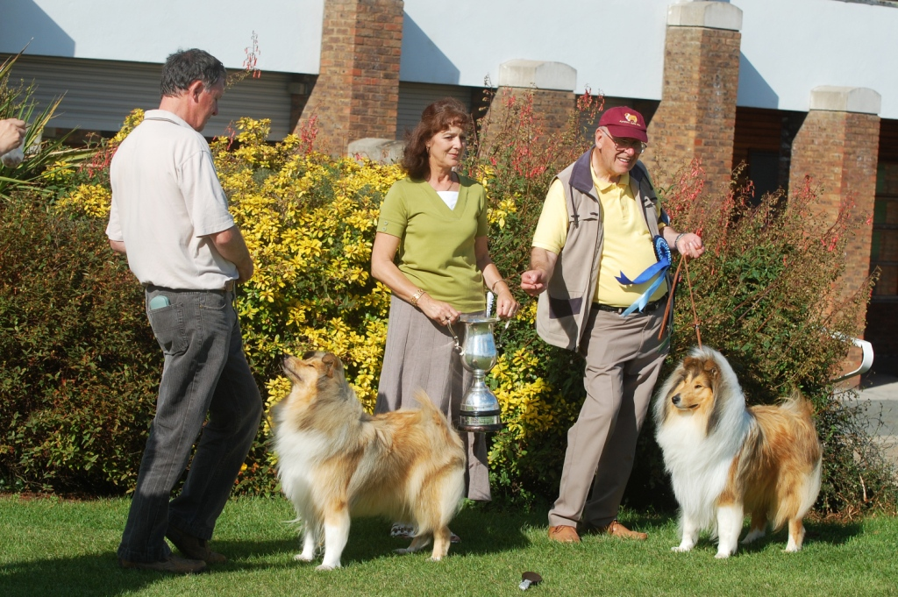
Green Star Bitch/BEST IN SHOW - Dominick & Linda O'Brien's Belrah Molly's Delight at Domlin
Green Star Dog/Reserve BIS - David & Edith Thomson's Lomondvale Storm Petral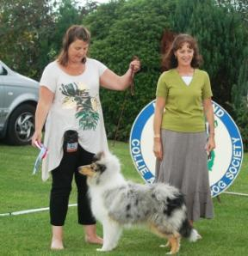
Best Puppy Dog/BEST PUP IN SHOW - Di & Reg Ware's Rochelle Bobby Dazzler at Wassail

New Champion August 2010
Congratulations to Liam Hodson and his champion, Ch Moyhill Ruby Tuesday, who gained her title in August 2010

New Champion June 2010
Congratulations to Peter Farrell and his champion, Ch Amalie Surprise at Belrah, who gained her title in June 2010

New Champion June 2010
Congratulations to Tom Wall and his champion, Ch Countrys Dream King For A Day, who gained his title in June 2010

Open Show 9th May 2010
Judge: Margo Walker (Starlenga)
Best dog and Res BIS: Ch Caronlea Lord of The Dance (Karen O'Neill)
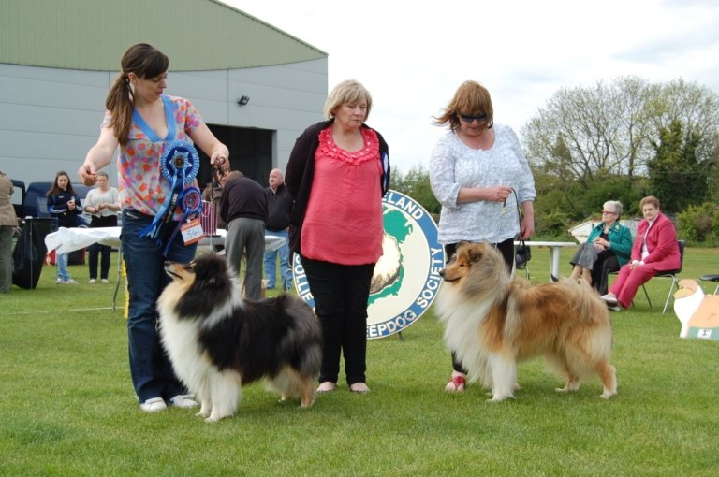
Reserve dog: Alwaycon Hip Hop (Tommy Conway)
Best bitch and Best In Show: Lynmead Lets Get Black at Wassail (Karen O'Neill and Di Ware)
Reserve bitch: Belrah Molly's Delight at Domlin (Dominick and Linda O'Brien)
Best Puppy in Show: Donohill Captain America (Maurice Carr and Mary Colclough)

New Champion
Congratulations to Mary McNally and her latest champion Ch Copamage Jackflash, who gained his title April 2010

New Champion
Congratulations to Mary McNally and her latest champion, Ch Copamage Make It Majic, who gained her title Dec 09

New Champion
Gained his title in October 09 - congratulations to Dominick and Linda O'Brien with Ch Belrah Harrys Delight at Domlin

New Champion
Gained her title in September 2009 (subject to IKC confirmation) - Congratulations to Peter Farrell with Ch Amalie Loves to Love (owned by Hollywood, Waterhouse & Farrell)

Champ Show 23rd August 2009
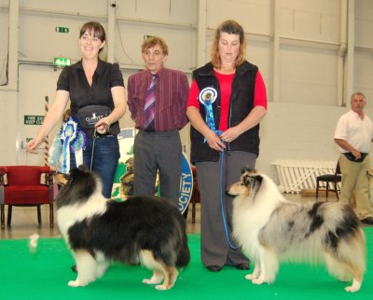
Judge Brian Hawkins (Brilyn)
Green Star Dog: K O'Neill - Caronlea Lord of the Dance JnrCh (and his champion title subjec to IKC approval)
Reserve: K O'Neill - Caronlea James Bond
Green Star Bitch: K O'Neill - Caronlea Dixie Chick JnrCh (Best in Show)
Reserve: D Ware - Ch Alouette Bleue Des Marcages do Prince to Wassail (Reserve Best in Show)
Best Pup in Show: P Farrell - Belrah Simply Surprise

Competition Winners 2009
Green Star Dog of the Year: Liam Hodson's Ch Prince Edward of Stonetown at Moyhill
Green Star Bitch of the Year: Tom Wall's Ch Sole Survivor at Dallyhaa
Pup/Junior of the Year: Eileen Seale's Caronlea Black Jack of Rowlands
Circuit Points Trophy Competition: Joint Winners - Peter Farrell's Amalie Loves to Love AND Eileen Seale's Caronlea Black Jack at Rowlands

New Champions
Two new champion dogs crowned in August 2009.
Congratulations to Liam Hodson with Champion Prince Edward of Stonetown at Moyhill
and Congratulations to Karen O'Neill with Champion Caronlea Lord of the Dance

Changes in the International Show Awards

IKC - Wednesday, July 29, 2009
the Irish Kennel Club has changed the system for the awarding of Best of Breed at International shows.

"Unbeaten dogs (male) graded excellent with the exception of puppies will challenge for Green Star and Reserve Green Star. When this is decided eligible dogs will then challenge for the CACIB and Reserve CACIB. The same procedure will follow for bitches. The Green Star Dog and Green Star Bitch winners will then challenge for Best of Breed. "

Annual General Meeting
the AGM will take place on Tuesday 6th October 2009 at 8 pm at the IKC Show Centre, Cloghran, Dublin. Only fully paid-up members are entitled to attend

Champ Show 23rd August 2009
- Schedules now available for Champ Show Sunday 23rd August 2009—judge Brian Hawkins (Brilyn)
click here for Schedule

Club Competitions - 2008 Club Competition Results:-
AICSS 2008 Green Star Bitch of the Year -Karen Tiernan's Valeo Bronte Belle
AICSS 2008 Green Star Dog of the Year -Dermot and Maureen Timmins' Ch Kynan Vanilla Sky
AICSS 2008 Pup of the Year - Peter Farrell's Amalie Surprise at Belrah
Circuit Points Trophy competition winner….Peter Farrell's Amalie Surprise at Belrah
click here for Rules of Club Competitions

Members' Announcements
- New Champion 2009—Congratulations to Tom Wall, whose blue bitch Sole Survivor at Dallyhaa gained her title May 2009
- New Champion 2009—Congratulations to Di Ware, whose blue bitch Aloutte Bleue Des Marecages’ Du Prince to Wassail. gained her title May 2009

Special Champ Show 29th May 2009

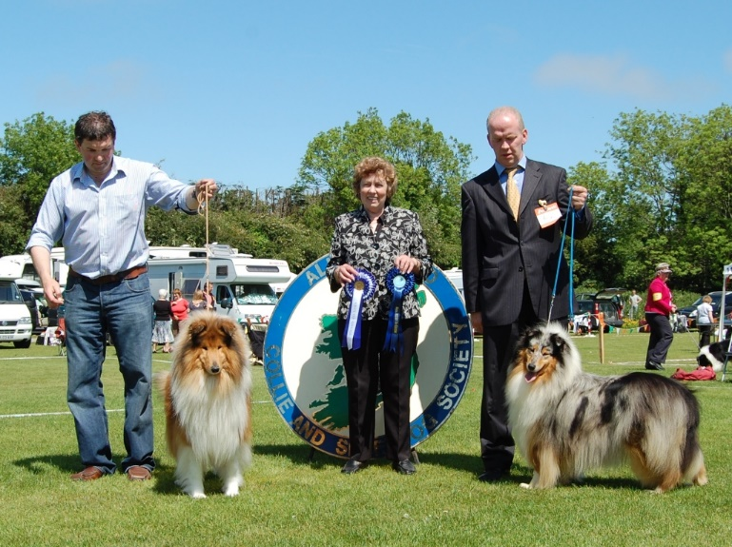

Best In Show.....
Left to Right: Liam Kelly with Ballahanna Belfast Boy , Judge Eleanor Kitchen, Tom Wall with Ch Sole Survivor at Dallyhaa

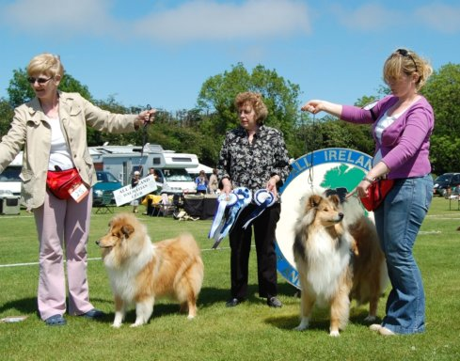
Best Pup in Show…..
Left to Right: - Joan McIntyre with Best Puppy Amalie Let Me Dream,(owned by Walker & McIntyre) Judge Eleanor Kitchen, Karen Tiernan with Valeo V.I.P.

