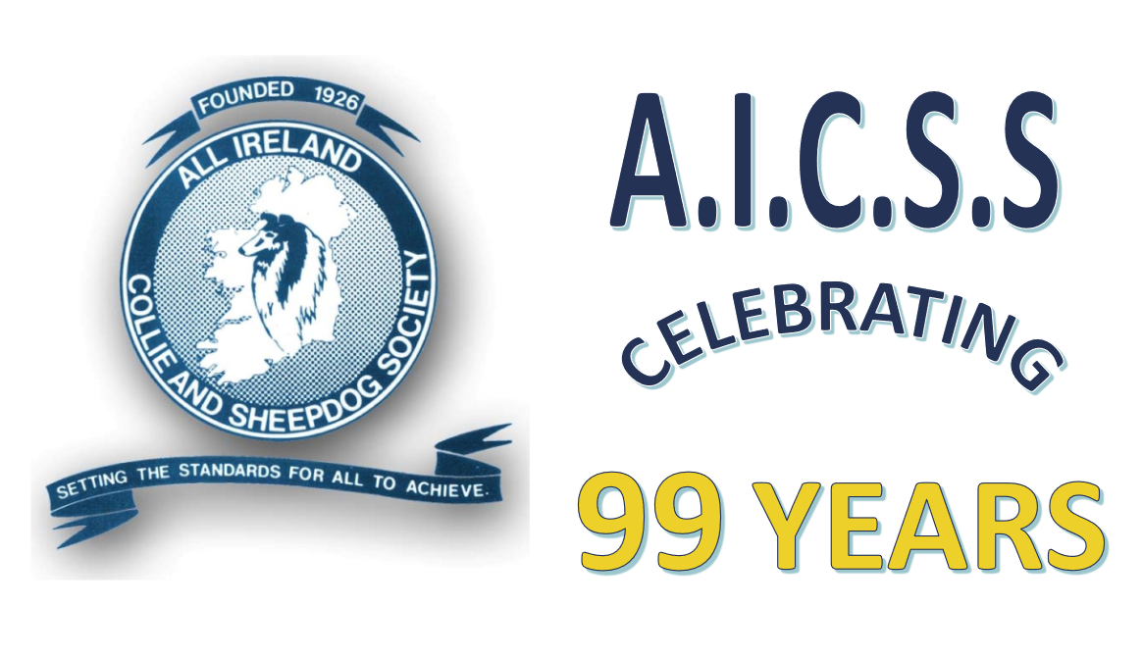

**January 2025**

|  |  |  |  |  |  |  |
| --- | --- | --- | --- | --- | --- | --- |
| Monday | Tuesday | Wednesday | Thursday | Friday | Saturday | Sunday |
|  |  | 1. | 2. | 3. | 4. | 5. |
| 6. | 7. | 8. | 9. | 10. | 11. | 12.  Bulldog Club Of Ireland; All Breed Open; National Show Centre Cloghran |
| 13. | 14. | 15. | 16. | 17. | 18.  Bulldog Club Of Ireland all br open – Cloghran, co Dublin | 19. |
| 20. | 21. | 22. | 23. | 24. | 25. | 26.  Shih Tzu Club Of Ireland - Limited Show;  Dublin Cocker Spaniel Society & Cocker Spaniel Club Of Ireland – all br open shows; NSC, Cloghran Co Dublin |
| 27. | 28. | 29. | 30. | 31. |  |  |



**February 2025**

|  |  |  |  |  |  |  |
| --- | --- | --- | --- | --- | --- | --- |
| Monday | Tuesday | Wednesday | Thursday | Friday | Saturday | Sunday |
|  |  |  |  |  | 1. | 2.  Tralee & District Canine Club; all br open; Castleisland Co Kerry |
| 3. | 4. | 5. | 6. | 7. | 8.  Wexford & District Canine Club; all br open; Olygate Co Wexford | 9. |
| 10. | 11. | 12. | 13. | 14. | 15. | 16.  Sullivans Quay Canine Club; all br open; Fermloy Cork |
| 17. | 18. | 19. | 20. | 21. | 22. | 23.  Mid West Canine Club; all br open; TheHub,Castlerea, Co. Roscommon |
| 24. | 25. | 26. | 27. | 28. |  |  |



**March 2025**

|  |  |  |  |  |  |  |
| --- | --- | --- | --- | --- | --- | --- |
| Monday | Tuesday | Wednesday | Thursday | Friday | Saturday | Sunday |
|  |  |  |  |  | 1. The Irish Great Dane Club, all br open, Cloghran, co Dublin | 2.  South Tipperary Canine Club; all br open; Thurles Co Tipperary |
| 3. | 4. | 5. | 6. | 7. | 8. | 9. |
| 10. | 11. | 12. | 13. | 14. | 15.  Irish Kennel Club; CACIB; NSC, Cloghran, co Dublin | 16.  Irish Kennel Club, Celtic Winners; Crufts 2026 qualifier |
| 17. | 18. | 19. | 20. | 21. | 22. | 23.  Munster Agricultural Society; all br open; Ballinora GAA Hall Cork. |
| 24. | 25. | 26. | 27. | 28. | 29. | 30 |



**April 2025**

|  |  |  |  |  |  |  |
| --- | --- | --- | --- | --- | --- | --- |
| Monday | Tuesday | Wednesday | Thursday | Friday | Saturday | Sunday |
|  | 1. | 2. | 3. | 4. | 5.  Mid West Canine Club; Championship; Roscommon Racecourse | 6.  Tralee & District Canine Club; all br open; Castleisland co Kerry |
| 7. | 8. | 9. | 10. | 11. | 12. | 13. |
| 14. | 15. | 16. | 17. | 18. | 19.  Combined Canine Club; CACIB; Naas Racecourse Co Kildare | 20.  Combined Canine Club; Championship Naas Racecourse Co Kildare |
| 21. | 22. | 23. | 24. | 25. | 26. | 27. |
| 28. | 29. | 30. |  |  |  |  |



**May 2025**

|  |  |  |  |  |  |  |
| --- | --- | --- | --- | --- | --- | --- |
| Monday | Tuesday | Wednesday | Thursday | Friday | Saturday | Sunday |
|  |  |  | 1. | 2. | 3.  South Tipperary Canine Club; Championship; Thurles Co Tipperary | 4.  Fermoy Canine Club; CACIB; Ferryhouse Clonmel |
| 5. | 6. | 7. | 8. | 9. | 10.  Hibernian All Breed Dog Club; Championship  A.I.C.S.S Breed Open Show;  judge: Michelle Davis (Rosschell) UK  NSC, Cloghran,co. Dublin | 11.  Drogheda & District Show Association; Championship; NSC, Cloghran, co. Dublin |
| 12. | 13. | 14. | 15. | 16. | 17.  Irish Gundog Field & Show Society; all br open; NSC, Cloghran, co.Dublin | 18. |
| 19. | 20. | 21. | 22. | 23. | 24.  Belgian Shepherd Dog Club Of Ireland; Gr 1 Championship; Naas Racecourse, co. Kildare | 25.  Navan Dog Club; Group Championship ; Naas Racecourse, co Kildare |
| 26. | 27. | 28. | 29. | 30. | 31.  Munster Canine Association; Championship; Fermoy Co Cork |  |



**June 2025**

|  |  |  |  |  |  |  |
| --- | --- | --- | --- | --- | --- | --- |
| Monday | Tuesday | Wednesday | Thursday | Friday | Saturday | Sunday |
|  |  |  |  |  |  | 1.  Cork & District Canine Club; Championship; Mallow Sports Complex |
| 2. | 3. | 4. | 5. | 6. | 7.  Wexford & District Canine Club; championship; Faythe Harries Sports Complex Co Wexford | 8. |
| 9. | 10. | 11. | 12. | 13. | 14.  Banbridge & District Canine Club; CACIB; Ulster Flying Club Newtownards | 15.  Banbridge & District Canine Club; Championship; Ulster Flying Club Newtownards |
| 16. | 17. | 18. | 19. | 20. | 21.  Swords & District Canine Society; Championship; NSC, Cloghran, co. Dublin | 22. |
| 23. | 24. | 25. | 26. | 27. | 28.  Kilkenny & District Canine Club; Championship; Ballyragget, Co Kilkenny | 29.  Deise Canine Club; Championship; TBC |
| 30. |  |  |  |  |  |  |



**July 2025**

|  |  |  |  |  |  |  |
| --- | --- | --- | --- | --- | --- | --- |
| Monday | Tuesday | Wednesday | Thursday | Friday | Saturday | Sunday |
|  | 1. | 2. | 3. | 4. | 5.  Bray & District Canine Society; Championship; NSC, Cloghran, co. Dublin | 6. |
| 7. | 8. | 9. | 10. | 11. | 12.  Irish Ladies Kennel Association; Championship;  A.I.C.S.S. Breed Championship;  judge: Michael Wirth (Dirty Booties)  NSC, Cloghran, co. Dublin | 13. |
| 14. | 15. | 16. | 17. | 18. | 19.  Sligo & District Canine Club; Championship; Clonguish GAA Longford | 20. |
| 21. | 22. | 23. | 24. | 25. | 26.  Munster Agricultural Society; Championship; AM & PM Munster Agr Canine Grounds Cork | 27.  Munster Agricultural Society; CACIB; Munster Agr Canine Grounds Cork |
| 28. | 29. | 30. | 31. |  |  |  |



**August 2025**

|  |  |  |  |  |  |  |
| --- | --- | --- | --- | --- | --- | --- |
| Monday | Tuesday | Wednesday | Thursday | Friday | Saturday | Sunday |
|  |  |  |  | 1. | 2.  Newtownards & District Canine Club; Championship; Ards Rugby Club Newtownards | 3.  Dun Laoghaire Canine Society; Championship; NSC, Cloghran, co. Dublin |
| 4. | 5. | 6. | 7. | 8. | 9.  Coleraine Canine Club; Championship; Ballymoney Show Grounds Co Antrim | 10. |
| 11. | 12. | 13. | 14. | 15. | 16. | 17.  Clonmel & District Canine Club; Championship; Clonmel, Co Tipperary |
| 18. | 19.  Killarney & District Canine Club; Championship; TBC | 20. | 21.  Limerick & District Canine Club; Championship; Adare Co Limerick | 22. | 23.  Tralee & District Canine Club; Championship; Castleisland Co Kerry | 24. |
| 25. | 26. | 27. | 28. | 29. | 30.  Portadown Canine Club; Championship; Lurgan Park Co Armagh | 31.  Munster Agricultural Society; all br open; Munster Agr Canine Grounds Cork |



**September 2025**

|  |  |  |  |  |  |  |
| --- | --- | --- | --- | --- | --- | --- |
| Monday | Tuesday | Wednesday | Thursday | Friday | Saturday | Sunday |
| 1. | 2. | 3. | 4. | 5. | 6.  Bangor & North Down Canine Club; CACIB; Ulster Flying Club, Newtownards | 7.  Bangor & North Down Canine Club; championship; Ulster Flying Club, Newtownards |
| 8. | 9. | 10. | 11. | 12. | 13. | 14. |
| 15. | 16. | 17. | 18. | 19. | 20.  Carlow & District Canine Club; Championship; Carlow Town Hurling Club | 21.  Wexford & District Canine Club; all br open; Olygate Co Wexford |
| 22. | 23. | 24. | 25. | 26. | 27. | 28. |
| 29. | 30. |  |  |  |  |  |



**October 2025**

|  |  |  |  |  |  |  |
| --- | --- | --- | --- | --- | --- | --- |
| Monday | Tuesday | Wednesday | Thursday | Friday | Saturday | Sunday |
|  |  | 1. | 2. | 3. | 4.  IKC; CACIB;  NSC, Cloghran, co. Dublin | 5.  IKC; Championship; NSC, Cloghran, co. Dublin |
| 6. | 7. | 8. | 9. | 10. | 11.  Papillon and Phalene Club Of Ireland, all br open, Cloghran, co Dublin | 12.  Tralee & District Canine Club; all br open; Castleisland, Co Kerry |
| 13. | 14. | 15. | 16. | 17. | 18. | 19.  Sliabhardagh Canine Society; all br open; CJ Kickhams GAA Centre Mullinahone |
| 20. | 21. | 22. | 23. | 24. | 25. | 26. |
| 27.  All Ireland Bull Breeds Association; Championship; NSC, Cloghran, co. Dublin | 28. | 29. | 30. | 31. |  |  |



**November 2025**

|  |  |  |  |  |  |  |
| --- | --- | --- | --- | --- | --- | --- |
| Monday | Tuesday | Wednesday | Thursday | Friday | Saturday | Sunday |
|  |  |  |  |  | 1. | 2. |
| 3. | 4. | 5. | 6. | 7. | 8. | 9.  Fermoy Canine Club; Members Show; Ferryhouse Clonmel Co Tipperary; |
| 10. | 11. | 12. | 13. | 14. | 15. | 16. |
| 17. | 18. | 19. | 20. | 21. | 22. | 23. |
| 24. | 25. | 26. | 27. | 28. | 29. | 30.  Munster Boxer Club; all br open; Waterford |



**December 2025**

|  |  |  |  |  |  |  |
| --- | --- | --- | --- | --- | --- | --- |
| Monday | Tuesday | Wednesday | Thursday | Friday | Saturday | Sunday |
| 1. | 2. | 3. | 4. | 5. | 6. | 7. |
| 8. | 9. | 10. | 11. | 12. | 13. | 14.  Drogheda & District Show Association; all br open show; NSC, Cloghran, co.Dublin |
| 15. | 16. | 17. | 18. | 19. | 20. | 21. |
| 22. | 23. | 24. | 25. | 26. | 27.  Dublin Dog Show Society; Championship; NSC, Cloghran, co. Dublin | 28. |
| 29. | 30. | 31. |  |  |  |  |

International Championship Shows CACIB

National Championship Shows Green Star

Open / Limit / Members Shows